Fachdidaktisches Proseminar 4: “Methodology of Teaching Literature and Culture”
Dr. Elisabeth Pölzleitner SS 2007

Term Paper

Lower school: Video
Extracts from


Handed in by
Eva Schachner
Table of Contents
Introduction 3
1) Pre- and while-viewing activities: 3
A) Crossword puzzle / word search 3
Word Search 4
Word Search - Solution 5
Crossword Puzzle 6
Cards 7
B) From transcript to voice 8
Transcripts 9
C) Silent Viewing 10
D) Prediction 10
E) Silent viewing + strip dialogue 10
F) Prediction 12
G) Gapped dialogue 12
2) Post-Viewing Activities 15
A) Vocabulary Work 15
B) Story-writing 15
Homework tasks: 15
C) Discussion of animal rights 16
Homework Tasks 18

Introduction

I chose extracts from the film “Chicken Run” for year three. I think that the film is suitable for all ages, and the language is not too difficult. However, the texts and activities I want to do after working on the video are rather challenging.
The material is designed for a few lessons, depending on how fast the class is. The video is a starting point (a) for having fun while watching an English film and doing language activities, (b) for writing a story, (c) for a discussion of animal rights (problem of laying hens being kept in cages - cruelty to animals).

1) Pre- and while-viewing activities:

Right at the beginning of the first lesson, I start with a game of hangman to find the title of the film from which we are going watch extracts. If a student calls out a letter that is not in the title, s/he is out of the game. When we have found the title, we start with the activities. Instead of Hangman, you could also use word circles or word clouds
C
h e r
u c n i k n
e.g.
.

Crossword puzzle / word search

To make the students familiar with new words, I give them a crossword puzzle. They also get cards with pictures and words on them to help them find the answers. After the crossword puzzle, they can do the word search. Or those who have finished the crossword puzzle quickly can do the word search while the others are working. The word search is rather difficult (words written in all directions).
Words used: tea set / necklace / pendant / coop / minuscule / turnip /pluck /stuff / roast
Crossword puzzle / word search puzzle and cards are on the next pages.

Word Search
P | F | F | U | T | S | K | M | X | E | T | F | T | L | T
B | E | V | E | P | C | S | F | L | I | H | N | E | P | U
Z | I | N | L | U | I | N | U | J | U | W | L | A | O | H
H | Y | U | D | N | E | C | K | L | A | C | E | S | O | Q
R | C | J | E | A | S | U | U | M | A | E | F | E | C | T
K | T | M | D | U | N | S | T | B | T | Y | B | T | M | V
F | B | B | N | O | Y | T | P | Y | V | M | B | H | N | G
F | S | I | G | R | O | W | A | M | T | R | S | J | P | G
F | M | S | P | M | B | T | V | T | N | Y | X | V | N | K
G | C | G | V | M | B | O | O | L | Y | B | Y | Y | S | D
V | F | G | K | L | K | T | X | H | N | E | Z | A | M | X
Y | R | E | Z | L | P | R | S | B | U | A | G | C | T | A
T | H | L | Q | G | F | N | C | A | V | M | Q | V | Q | P
F | X | F | Q | G | P | B | V | S | O | K | N | Z | T | Y
W | D | S | T | O | V | U | M | V | A | R | K | D | O | Y

COOP | MINUSCULE | NECKLACE
PENDANT | PLUCK | ROAST
STUFF | TEASET

Word Search - Solution

P F F U T S + + + E + + T + +
+ E + + P + + + L + + + E P +
+ + N L + + + U + + + + A O +
+ + U D N E C K L A C E S O +
+ C + + A S + + + + + + E C +
K + + + U N + + + + + + T + +
+ + + N + + T + + + + + + + +
+ + I + + + + + + + + + + + +
+ M + + + + + + + + + + + + +
+ + + + + + + + + + + + + + +
+ + + + + + T + + + + + + + +
+ + + + + + + S + + + + + + +
+ + + + + + + + A + + + + + +
+ + + + + + + + + O + + + + +
+ + + + + + + + + + R + + + +

(Over,Down,Direction)
COOP(14,5,N)
MINUSCULE(2,9,NE)
NECKLACE(5,4,E)
PENDANT(1,1,SE)
PLUCK(5,2,SW)
ROAST(11,15,NW)
STUFF(6,1,W)
TEASET(13,1,S)

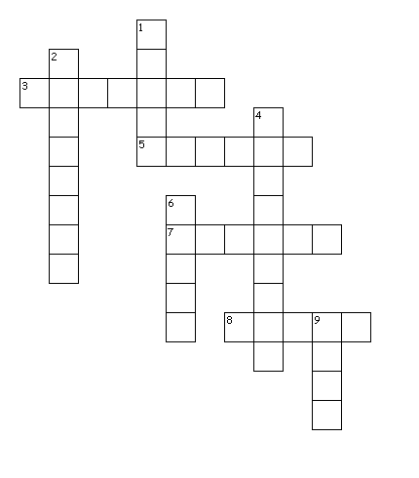
Crossword Puzzle

Across
3. ornament on a chain worn round the neck
5. round greenish-white vegetable
7. teapot, cups, saucers (two words)
8. pull out feathers for cooking
Down
1. cook in the oven
2. a piece of jewellery worn round the neck
4. very small
6. fill with something
9. cage for chicken or rabbits

Crossword Puzzle

Across
3. ornament on a chain worn round the neck
5. round greenish-white vegetable
7. teapot, cups, saucers (two words)
8. pull out feathers for cooking
Down
1. cook in the oven
2. a piece of jewellery worn round the neck
4. very small
6. fill with something
9. cage for chicken or rabbits

Cards
tea set | necklace
pendant | coop
minuscule | turnip
roast | stuff

pluck

B) From transcript to voice

The first passage (track 4 of the DVD, time: 10:33 – 12:14) is transcribed without indication as to who is speaking. Actually, I would do two versions (graded exercise): one without any punctuation and one with punctuation. Depending on the class, I would either give the version without punctuation to everyone and hand out the easier version only if there are major problems, or only to students who have problems, or I could give the more difficult version to better students. It would probably be better to let them choose whether they want the easy version (so not to say “You are not good enough!”).
The transcripts are on a new page so you (my colleagues) can copy it more easily.
Students look at their sheets, first individually, then in pairs. They compare their solutions. Then they guess who is speaking. They can discuss this in groups of three, or as a whole class. Students take short notes of their ideas as to who is speaking, what is going on, where the story is set etc. I tell them to be inventive and make up many different versions!

Transcripts

You called Nick and Fetcher at your service over here we need more things right you are miss how about this quality hand-made tea set ah no or this lovely necklace and pendant it`s lov- or this beautiful little number all the rage in the fashionable chicken coops in Paris simply pop it on like so and as the French hens say voilà that is French that’s two hats in one miss for parties for weddings Madame it’s like you look like a vision like a dream like a duck no thank you we’re making this we need these things can you get them aw ooh this is a big job miss bigger than the others this will cost same as always one bag of seed you call this pay it’s chicken feed what else could we give you eggs eggs eggs we can’t give you our eggs they’re too valuable and so are we after you Fetcher after I what move

You called? Nick and Fetcher at your service. Over here! We need more things. Right you are, Miss. How about this quality hand-made tea set? Ah no- Or this lovely necklace and pendant? It`s lov-… Or this beautiful little number! All the rage in the fashionable chicken coops in Paris! Simply pop it on, like so, and as the French hens say: voilà! That is French. That’s two hats in one, Miss. For parties. For weddings. Madame, it’s like you look like a vision, like a dream. Like a duck. No thank you. We’re making this. We need these things. Can you get them? Aw … ooh … This is a big job, Miss, bigger than the others. This will cost. Same as always: one bag of seed. You call this pay? It’s chicken feed. What else could we give you? Eggs. Eggs? Eggs. We can’t give you our eggs. They’re too valuable! And so are we. After you, Fetcher. After I what? Move!

C) Silent Viewing

After the discussions, we watch the scene without sound. The students watch and compare with their transcripts, correct if necessary. They find out who is who. Then we watch with sound.

D) Prediction

The students take notes (individually) of what they think the film is about. They guess how the story goes on, who else is in it etc. I allow about two to three minutes only. Then we go on to the next scene.

E) Silent viewing + strip dialogue

The next short scene is track 5 (12:15 – 14:00). I hand out the cut-up pieces of the dialogue and we discuss the language (in case there are comprehension problems). We watch without sound, and students try to order the dialogue. They can work with a partner. Maybe I have to play the scene twice.
There are two sets of strips so can photocopy the whole page if you want to use it.

Stupid, worthless creatures! I’m sick and tired of making minuscule profits.
Oh yes. Those chickens are up to something.
Quiet. I’m on to something.
Quiet!
They’re organized. That ginger one. I reckon she’s their leader.
Mr. Tweedy! I may finally have found a way to make some real money ‘round here.
And what are you on about? Ridiculous notions of escaping chickens!
It’s all in you head, Mr. Tweedy. Say it.
It’s all in my head. It’s all in my head.
Now. You keep telling yourself that because I don’t want to hear another word about it.
Is that clear?
Yes, love.
But you know, that ginger one…
They’re chickens, you dolt! Apart from you, they’re the most stupid creatures on this planet!
They don’t plot, they don’t scheme, and they are not organized!

Stupid, worthless creatures! I’m sick and tired of making minuscule profits.
Oh yes. Those chickens are up to something.
Quiet. I’m on to something.
Quiet!
They’re organized. That ginger one. I reckon she’s their leader.
Mr. Tweedy! I may finally have found a way to make some real money ‘round here.
And what are you on about? Ridiculous notions of escaping chickens!
It’s all in you head, Mr. Tweedy. Say it.
It’s all in my head. It’s all in my head.
Now. You keep telling yourself that because I don’t want to hear another word about it.
Is that clear?
Yes, love.
But you know, that ginger one…
They’re chickens, you dolt! Apart from you, they’re the most stupid creatures on this planet!
They don’t plot, they don’t scheme, and they are not organized!

F) Prediction

Now it is time for another prediction. First of all, we discuss who the two persons are and whether the students guessed there would be farm-owners involved etc. Then the students again take short notes about how the film goes on, how the hens are organized etc. (again only two to three minutes).
Then we move on to the next scene (track 6, time: 14:01 - 17:30)

G) Gapped dialogue

We watch the scene. Then the students get a gapped version of the dialogue. There are two versions with different gaps. They complete their dialogues in pairs and then each student teams up with a new partner to compare and correct if necessary.
Again, I put each dialogue on a separate sheet so you can copy it.
Ginger: Order! Order! Quiet everyone! Settle down. I would like to
______ _____ __________. Please –
Fowler: Quiet! _______________ in the ranks! What what!
Ginger: Thank you, Fowler.
Fowler: In my RAF* days, we were never allowed to waste time with unnecessary chitchat!
Ginger: Yes, thank you, Fowler.
Fowler: ___________. Carry on.
Ginger: Now, I know our last escape attempt was a bit of a fiasco, but Mac and I have come up with a brand new plan. Show them, Mac.
Mac: Right. We tried going _____ ______ ______, and that didn’t work. So, the plan is: we go over it. This is us, right? We get in ______ ________, and wind her up, and _____ ____ _____!
Fowler: Good grief! The turnip’s bought it!
Chicken: Farmer’s coming!
Fowler: Operation cover-up!
Mrs. Tweedy: Mr. Tweedy! _________ _____ ______?
Mr. Tweedy: It’s all in your head. It’s all in your head. It’s all in your head.
Ginger: _____________, everyone, ____________. What haven’t we tried yet?
Bunty: We haven’t tried not trying to escape.
Babs: That might ____________!
Ginger: What about Edwina? How many more empty nests will it take?
Bunty: Perhaps it wouldn’t be empty if she had spent _______ _______ laying and less time ______________.
Ginger: So laying eggs all your life and then getting plucked, stuffed and roasted is __________ ____________ for you?
Babs: It’s a living.
Ginger: You know what the _______________ is. The fences aren’t just around the farm, they’re up here. In your heads! There is a better place out there. Somewhere beyond that hill, it has wide open _______________ and lots of _________. And grass. Can you imagine that? __________, green grass.
Chicken: Who feeds us?
Ginger: We feed ______________.
Chicken: Where’s the farm?
Ginger: There is no _________.
Babs: Then where does the farmer live?
Ginger: There is no ____________, Babs.
Babs: Is he on holiday?
Ginger: He isn’t anywhere. Don’t you get it? There’s no morning egg count, no farmers, no _________, no coops and ___________ and no fences!
Bunty: In all my life, I’ve never heard such a fantastic … load of tripe! Face the facts, ducks! The __________ of us getting out are a million to one.
Ginger: Then there’s still a chance.

* RAF = Royal Air Force

Ginger: Order! Order! ________ __________! Settle down. I would like to
call to order …. Please –
Fowler: Quiet! Discipline in the ranks! What what!
Ginger: Thank you, Fowler.
Fowler: In my RAF* days, we were never allowed to _______ ______ with unnecessary chitchat!
Ginger: Yes, thank you, Fowler.
Fowler: Right. Ahem. Carry on.
Ginger: Now, I know our last escape attempt was a bit of a fiasco, but Mac and I have come up with a _____ ____ _______. Show them, Mac.
Mac: Right. We tried going under the wire, and that didn’t work. So, the plan is: we go ________ __. This is us, right? We get in like this, and wind her up, and let her go!
Fowler: Good grief! The turnip’s bought it!
Chicken: ________ _________!
Fowler: Operation cover-up!
Mrs. Tweedy: Mr. Tweedy! Where are you?
Mr. Tweedy: ______________________.___________________._________________.
Ginger: Think, everyone, think. What haven’t we tried yet?
Bunty: We haven’t tried ____ _________ to escape.
Babs: That might work!
Ginger: What about Edwina? How many more ________ _______ will it take?
Bunty: Perhaps it wouldn’t be empty if she had spent more time laying and less time escaping!
Ginger: So _________ _____all your life and then getting plucked, stuffed and roasted is good enough for you?
Babs: It’s a living.
Ginger: You know what the problem is. The ___________ aren’t just around the farm, they’re up here. In your _______! There is a better place out there. Somewhere beyond that hill, it has wide open spaces and lots of trees. And ______. Can you imagine that? Cool, _______ _________.
Chicken: Who ______ us?
Ginger: We feed ourselves.
Chicken: Where’s the______?
Ginger: There is no farm.
Babs: Then where does the ________live?
Ginger: There is no farmer, Babs.
Babs: Is he on ____________?
Ginger: He isn’t __________. Don’t you get it? There’s no morning egg count, no farmers, no dogs, no _______and keys and no ________!
Bunty: In all my life, I’ve never heard such a _________ … load of tripe! Face the facts, ducks! The chances of us getting out are a ___________ to one.
Ginger: Then there’s still a _________.

* RAF = Royal Air Force

2) Post-Viewing Activities

A) Vocabulary Work

As the students have only encountered single words in the crossword and word search puzzle, it is important to teach them phrases to go with them. As a homework, they have to find a whole phrase for each of the words, either from the film or from a different context. Furthermore, each student has to find three phrases, either in the strip dialogue or in the gapped dialogue, which s/he wants to remember, and write them in their vocab book or on a card. In the next lesson, I ask some students to read out their phrases. As they cannot check themselves whether they are correct, I have a quick look through their phrases to make sure they are correct.

B) Story-writing

Apart from going through the dialogue and talking about language points and difficulties, the most important post-viewing task is creating a story. For homework, the students come up with their personal version of how the story goes on. They can use the notes which they have made during the activities or invent something completely new.
Their story can be written from different points of view which we are going to discuss: they can either choose to write as a third person narrator or from the point of view of one character they choose. I give them examples for both. We revise what is most important when writing a story (recipe), and talk about the characters (who is in the story, who is important, etc.).
Depending on the class and whether they are still interested in doing it, we could also make books out of their stories; or we could publish a class magazine with all the different versions in it.

Homework tasks:
1) Continue the story of “Chicken Run” as a third-person narrator (you are not a character in the story). Remember our “Recipe” and make your story full of details, interesting, and fun to read! OR:
2) Continue the story from the point of view of one character (You are Ginger, or MR. Tweedy, …). Remember that a first-person narrator cannot know everything!

C) Discussion of animal rights

I think that at the age of 12 or 13, the students are probably interested in the topic.
I show them a picture of hens in battery cages. I ask them to tell me what they see and how the picture makes them feel. Then we discuss how laying hens are being kept (they probably know that in our supermarkets, we can buy eggs from hens living in battery cages, but also from hens running around in a bigger confinement, free range eggs).
http://www.all-creatures.org/articles/egg-battery.html
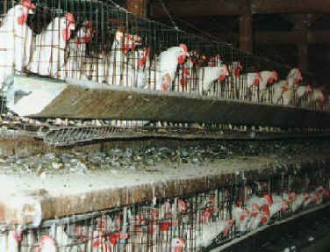

I show them the egg codes for Great Britain, so they can compare to what they see in Austrian supermarkets.
Shelling out
By law, all EU produced eggs should be stamped on their shells with a code to indicate their provenance. Apart from other codes and logos, there must be a string of numbers and letters that look something like this: 3UK123c. The first number indicates the stocking conditions, based on the code shown below. In this example these would be eggs from caged hens.
0 = organic
1 = free range
2 = barn eggs
3 = cage eggs
This initial code is followed by the country, such as UK, and the farm’s identity number (in this example a fictitious 123c).
http://www.foodcomm.org.uk/latest_scrambled_eggs_jan05.htm
We then discuss which kind of eggs they buy (or their parents buy), whether there is a special reason for doing so, and what they think about it. It’s very important to allow every opinion and to make clear to the students that they give arguments without insulting the others.
If it is possible at school, or else as a homework, they can do some research on the sites I give them. It would of course be better to do it at school because the language used on the web pages may be quite challenging. If we can’t do the research at school, I explain to the students that it is okay if they only understand little. They are meant to find out enough to write a short text in which they express their opinion about how hens are being kept and supply a few arguments to support their view.
For a weaker class who would not be able to cope with the authentic internet articles, I would look for easily understandable texts or modify some texts.

http://www.thehenshouse.co.uk/
http://www.animal-lib.org.au/lists/hens/hens.shtml
http://www.downthelane.net/battery.html (explains different ways of egg production, i.e. barn eggs, free range eggs)
http://www.all-creatures.org/articles/egg-battery.html
http://www.upc-online.org/battery_hens/
http://www.upc-online.org/spring05/lifeofhen.htm (a poem)
http://news.bbc.co.uk/1/hi/uk/264607.stm
http://www.atourhands.com/battery.html
http://www.hsus.org/farm/camp/nbe/compare.html
http://www.hsus.org/farm/resources/pubs/animal_welfare_claims_on_egg_cartons.html

There are also some cartoons (and one photo) which I would use as discussion starters; I would put the students in groups of 4/5 and give a different cartoon to each group. They discuss what they see and then discuss their cartoons with members of other groups.
I would eventually give all the cartoons to all the students. They choose one and write any kind of text about it – a poem, a story, a newspaper article… Their texts can be published together with their “Chicken Run” stories if they want to.

Homework Tasks

Choose ONE cartoon…
- … and write a poem/song lyrics related to it. OR:
- … and write a newspaper article related to it (e.g. about an animal rights organization freeing chickens etc.). OR:
- … and write a story related to it (using the characters you see in the cartoon). OR:
- … and explain in detail what you see, what you think about it, how it makes you feel, what you think the artist wanted to convey, and give your opinion on battery hens.
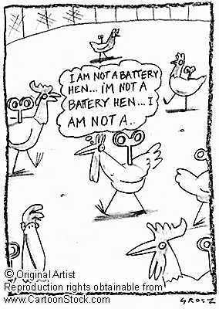
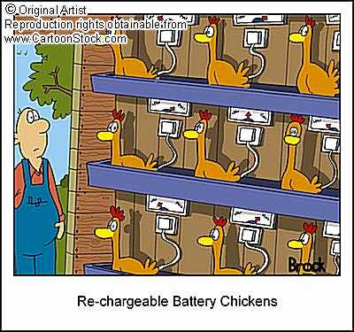

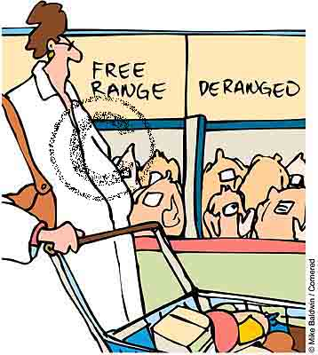

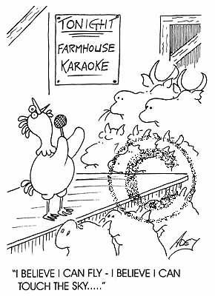

http://www.cartoonstock.com/
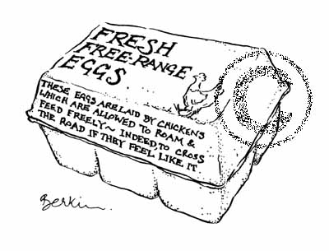

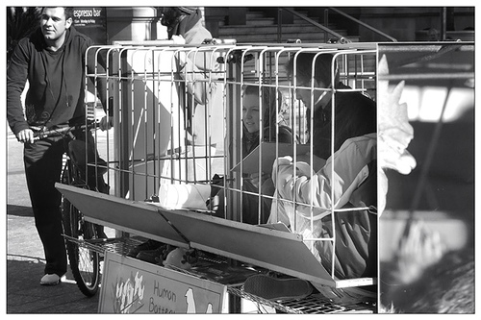

http://www.flickr.com/photos/martin-lambert/637932127/

Chicken Run (2000), tobis studio canal+ and Dreamworks Pictures

