Literature Projects
511.440 Methodology of Teaching Literature and Culture (Fachdidaktisches PS 4) - WS 2009/10
Dr.phil. Elisabeth Pölzleitner

Gernot Schirmbacher (0130901)
Villefortgasse 5, 8010 Graz
gernot.schirmbacher@gmail.com
+43 699 128 46 399
22nd of January, 2010

Introduction

My collection of tasks for the course “Methodology of Teaching Literature and Culture” consists of two major parts. The first one is called “Halloween” focusing on the very same topic and is designed for 4th grade. The second task is called “The Adventures of Huckleberry Finn” and is designed for 7th and/or 8th grade. The third worksheet that I have provided is based on “The Giver” and is supposed to be used in upper school.

The worksheet for “Halloween” has originally been designed for my “Schulpraktikum 2”, attended at the BG Ursulinen. It has proven itself to be working quite well, although some modifications have been made since its first usage.

“The Adventures of Huckleberry Finn” is a worksheet based on the novel of the same name. After having split up students into groups of four they are handed the assignment sheet. After having read the instructions to them they should be able to work on their own. It will be necessary, or at least useful, to have at least one of the lessons in a computer lab. The fourth lesson should be supervised by the teacher, collecting the ideas from students and guide discussions.

I took inspiration for the worksheet to “The Giver” from an actual class of this course, when this book was roughly introduced to us. Since I love to draw and am convinced that everybody can draw I provide a more creative project. This project might be done either at the end of lower school or at the beginning of in upper school.
HALLOWEEN
Before you watch “This is Halloween” from Tim Burton’s “The Night Before Christmas” on YouTube (http://www.youtube.com/watch?v=xpvdAJYvofI) make sure you read through the tasks carefully!

Task I.
Take notes of everything you can see in the video that is related to Halloween.
If you can’t come up with the English term, think how you can explain it in English, make a little drawing or write down the German word (in emergency cases only!).

Task II. Halloween words:
Together with your colleagues we collect as many words related to Halloween as possible. Be prepared to contribute!

Task III.
With all the Halloween-words you now have, write a short (~ 300 words) Halloween story using some of them. Do not forget to use paragraphs as we have discussed over the last few weeks! Here are a few ideas how you might want to start your story:

It was a very dark and stormy night when…
I never really believed in Halloween but that night that changed...
It was Halloween evening and my mother told me that I was too old for trick-or-treating…
Some people say that Halloween is just a night like any other night but I beg to differ…
I always suspected my neighbor to be different but on Halloween’s eve…
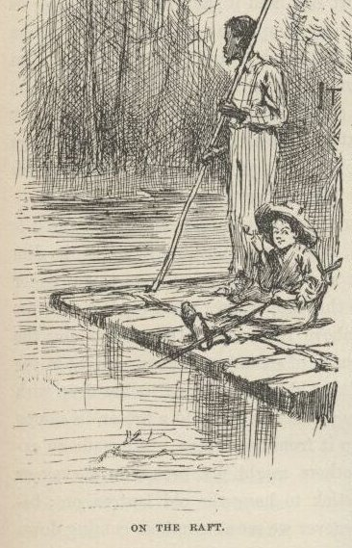
The Adventures of Huckleberry Finn
After having read “The Adventures of Huckleberry Finn” we will now work on some features that are described within the novel. Form groups of four and discuss the questions below. Make sure you read the instructions carefully.
This project last for four lessons:
The first lesson is today’s lesson, in which you split up the tasks within your group. Furthermore you should start gathering ideas for the questions asked.
The second and third lesson will take place in the computer lab. Please make sure you all bring your copy of “The Adventures of Huckleberry Finn”. You will be allowed to use your book and the internet to find proper answers. You should also be aware of the fact that you should use the last 30 minutes of lesson four to prepare your results to report in the last lesson.
In lesson four, some of you will be asked to report your answer for a question. In addition to that we will compare and discuss answers from other groups.
Since you will be chosen by chance, make sure everybody is prepared for the final lesson!
The Adventures of Huckleberry Finn
After having read “The Adventures of Huckleberry Finn” we will now work on some features that are described within the novel. Form groups of four and discuss the questions below. Make sure you read the instructions carefully.
This project last for four lessons:
The first lesson is today’s lesson, in which you split up the tasks within your group. Furthermore you should start gathering ideas for the questions asked.
The second and third lesson will take place in the computer lab. Please make sure you all bring your copy of “The Adventures of Huckleberry Finn”. You will be allowed to use your book and the internet to find proper answers. You should also be aware of the fact that you should use the last 30 minutes of lesson four to prepare your results to report in the last lesson.
In lesson four, some of you will be asked to report your answer for a question. In addition to that we will compare and discuss answers from other groups.
Since you will be chosen by chance, make sure everybody is prepared for the final lesson!

The Adventures of Huckleberry Finn - Question Pool

Question 1
Make a list of the different ways in which Huck portrays small-town life. What are the differences and similarities between the places he visits and travels?

Question 2
Make a list of the different roles women play in the novel. Make sure you name characters and give examples from the text.

Question 3
Make a list of the different ways in which Tom Sawyer and Huck Finn are different or similar. Make sure you give specific evidence from the text.

Question 4
Make a list of the ways in which Huck is weak. Then make a list of the ways in which he is strong. Make sure you give specific examples from the text.

Question 5
Make a list of all the different tricks Huck uses in the novel so far. Which tricks does he play to help people? Which tricks does he play to hurt people? Use examples from the text to prove your statements.

The Giver
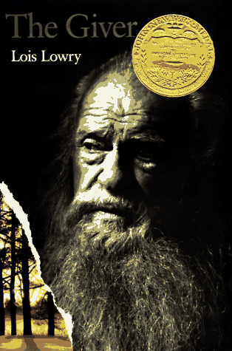
Below you will find 5 tasks which you should complete within two weeks. Two weeks are a long time, make sure you plan your activities properly so you do not lose track of time. You might consider doing task I, 2 and 3 in the first week and finish off with task 4 and 5 in week two.

Task I.
Think of items that were important in the book and chose three of them. Draw them and explain their relevance within the story.

Task 2.
Some of you might not have liked the ending. Come up with your own ending, starting at the end of the book. Explain what happens to Jonas later and how the story might really end.

Task 3.
Make a list of all of the important places which are mentioned in the story. Use all the clues that are given as well as your imagination to draw a map of the community.

Task 4.
Choose four characters from the book and create character cards (see separate sheet). You will have to add: a drawing, their name, their age, their job and a few lines about their personality.

Task 5.
Choose two important events from the book. Draw the event and explain why it is important to the story.

Now that you know what you have to produce, start by planning your activities over the next two weeks! If you have any questions or problems you can always come to see me.
At the end of the two weeks we will have a big presentation of your artworks.

Teacher’s note to ‘The Giver’
Either the large or the small version of the profile sheets can be chosen. To explain all the lines that are given on the profile pages I would recommend bringing in an already filled out template on a transparency. The name should be written in the very first line, the next line age and occupation should be filled in and so on.

Peer comment by Roman Kampus
Your worksheet ‘Halloween’ appears to be a lot of fun, since students are able to work on their own and playfully gain knowledge about Halloween and collect vocabulary. I cannot think of any changes that would have to be made.
I appreciate the fact that you have given a clear outline of when students should do what on the worksheet to ‘The Adventures of Huckleberry Finn’. Therefore they (hopefully) won’t lose track of time and finish their work punctually. In addition to your original worksheet you could create it for different time-spans. Furthermore you should make sure that the students will understand the terms “weak” and “play tricks” in the right context.
The worksheet “The Giver” provides a vague schedule for students although they are given the freedom to manage their own time. I believe that can be a great chance for them and their future time-management in various areas. You could think about adding a “halftime-check” to see how the students’ progress has come so far. I really have appreciated the teacher’s note you have added because I believe that the students would be left stranded if there wouldn’t be a template of some sort.

This is supposed to be done by the teacher individually since it would go beyond the scope of the written assignment.
I have turned that idea down since you as a teacher should always keep an eye on the progress of your students. Furthermore I don’t think that a separate check is efficient, depending on the number of students you have.

