Daniela Peter (0512165)
SS 2009
Dr. Pölzleitner, Elisabeth

PS 4 Methodology of teaching literature and culture


Table of contents
_Toc230747153
I. Introduction 3
II. Upper class film project 4
II.1 Supersize Me: background 4
II.1.1 The food project 4
II.1.2 Supersize Me – the film 4
II.2 Lesson progress 5
II.2.1 Instructions 5
II.2.2 Exercise overview 6
II.3 Lesson plan 7
II.4 Practical part: worksheets 8
II.5 Student’s checklist 22

III. Bibliography 23

Introduction

In the following term paper I have designed English lessons for lower and upper classes. I have tried to create a book project for younger students and therefore used the picture book “The very hungry caterpillar” written by Eric Carle. For the upper class project I decided to make a food project including the film “Supersize Me” produced by Morgan Spurlock.

In this term paper, I will first give some general descriptions and some theoretical background information of the topics I have chosen to give an insight into what will be covered. Then I will present the practical worksheets I made to support my lesson plans. This is done for both projects, the book project for the younger pupils and the film project for upper classes. Each project is designed for 2 to 4 sessions. Therefore, lesson plans, an aim analysis and lesson outlines are also attached in detail.

Upper class film project

III.1 Supersize Me: background

III.1.1 The food project
SUPER SIZE ME is a documentary film, which is in my opinion very useful as an input for discussions of the topic nutrition, fast-food, food advertising and obesity among children. It should be thought provoking and should encourage students to rethink their eating habits and start changing their food consumption into a more healthy way.

I, therefore, prepared a three to four lessons food project, where the children should get encouraged to think about their eating habits and for this reason I took the film “Supersize Me” to give them an input. As my experiences have shown, this project works very well at the fifth or sixth form. If the film is shown in a fourth class, which is possible as well, an English subtitle is needed in order to guarantee that the kids understand the film as it is a documentary film and full of information and facts.

III.1.2 Supersize Me – the film
Super Size Me is a 2004 documentary film directed by and starring Morgan Spurlock, an American independent filmmaker. Spurlock's film follows a 30-day time period (February to beginning of March 2003) during which he limits himself to only eat McDonald's food. The film documents this lifestyle’s drastic effects on Spurlock's physical and psychological well-being, and explores the fast food industry's corporate influence, including how it encourages poor nutrition for its own profit.

III.2 Lesson progress

III.2.1 Instructions
The worksheets are divided into pre-, while- and post viewing tasks. Most of them can be done at school but some will have to be finished at home as homework. For some exercises computers and internet access is necessary, therefore, a computer room should be organised.

During these prepared three lessons the students should keep a kind of portfolio where they collect all the material and texts they write and the worksheets they work on. Therefore, a checklist for the students is prepared where they can tick off the exercises they have already done and get an overview of what is still missing.
By the end of the fourth lesson the teacher should collect all the portfolio maps and correct them in order to guarantee a correct language progress and give feedback to the students.

III.2.2 Exercise overview

nr. | exercise | social form | aim
1 | Introduction: food habits | individual work | - getting to know one’s own food habits  - improvement of writing skills
2 | Introduction: an experiment and ABC-list | class work  individual work | - vocabulary collection
3 | Pre-viewing task: homework sheet | partner work  individual work | - interviewing people  - writing skills  - speaking skills
4 | Pre-viewing task: information sheet | partner work | - reading improvement
5 | Pre-viewing tasks: worksheet | partner work | - writing improvement  - vocabulary work
6 | While-viewing tasks:  Worksheet | individual work and partner work | - listening improvement
7 | Post-viewing tasks: worksheet | partner work and group work | - internet work  - writing improvement  - speaking improvement  - reading improvement  - listening improvement
8 | Summary | individual work | - writing improvement

III.3 Lesson plan
Time | Content | skill | Material | Contents
20 min | introduction | writing  speaking | food pieces for the experiment  worksheet (1) | getting to know one’s own food habits;
30 min | pre-viewing tasks | writing  speaking  reading | worksheets (3-5) | interviewing people  reading information about food  internet research
100 min | DVD watching and  While-viewing tasks | listening | DVD Supersize ME  worksheet (6) | DVD listening
50 min | post-viewing tasks | writing  speaking  reading  listening | worksheets 7 | information discussion
HW | Summary | writing  speaking | worksheet 8 | film review

III.4 Practical part: worksheets

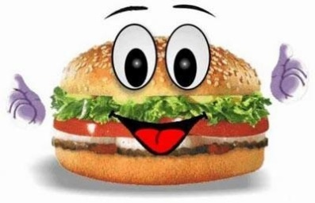
Introduction

Portfolio instructions

During the next few sessions you have to keep a film portfolio about the film “Supersize Me” and the topic nutrition. Generally, you have to include all the materials (worksheet, information sheets, homework…). This portfolio contains more or less material you will work on in class. But there is also homework to do before we start watching the film in school and you will have to finish all the worksheets you won’t be able to finish in class.

You will get a work plan with all contents that have to be in the portfolio and should be used as a checklist but you may also search for extra texts, material that matches the topic healthy nutrition and fast food and put it into your map.

E.g.: Make a personal profile about eating habits. And write a short text about what you expect of this film and the topic fast food as well as eating habits.

Pre-Viewing Activity

An experiment

- To start with and get a good start right into the topic food and fast food a kind of “blind taste testing” would be a very nice thing to do: Different food pieces have to be guessed by the students.

The aim of this exercise is to illustrate the children how good fresh food can taste and how reduced their tasting skills already are because of the enormous amounts of convenient food and fast food they normally eat.

- Make an ABC-list and write a word that comes to your mind when you think about food and nutrition in general. Leave out the letters you don’t know. After watching the film try to finish your ABC-list and write down words to the missing letters in a different colour. Do you know now more words than before and can you now finish the list?

Example (how it could look like)
A
Burger
Cholesterol
Diabetes
E
Fast Food
G
Healthy food
I
Junk Food...

Junk Food Fast Food

Junk food is ........................................... Fast food is …………………………………………
……………………………………………………………….….. …………………………………..……………………….
…………………………………………………………….…….. ………………………………………………………for
for example ………………………………………… example ………………………………………………
……………………………………………………………………… ……………………………………………………………….
…………………………………………………………………. It’s bad for you because …………………
………………………………………………………………
My favourite dish: ……………………….…………………………………..
…………………………………………………………………………………. …………………………………………………………………………….
Healthy Food
Vegetables, like ……………………………………………………………………………..……………………………………………………………..
………………………………………………………………… Fruit, like..…………………………………………………………………………………..
………………………………………………………………………………………………….………….. Other healthy food : …………………
…………………………………………………………………………………………………………………………………………………………………………..

Why do many people eat fast food? Why do children like Mc Donald’s etc.?
Because …………………………………………………………………..…………
Because……………………………………………………………………………… ………………………………………………………………………….……………
Because ……………………………………………………………………………… ………………………………………………………………….………………..…
Because ……………………………………………………………………………… ………………………………………………………………………..………………
Because ……………………………………………………………………………… ……………………………………………………………………………………….

.

Pre-Viewing Activity

Homework sheet

As homework you have to make your own investigation! Your job is it to ask your friends and family members about their fast food eating habits. You have to interview at least three different people.
Try to ask them the following questions and write a short report on what they told you.
- What is fast food?
- Where do you buy your fast food?
- What’s your favourite fast food chain?
- How often do you eat fast food?
- Would you say that you eat fast food too often?
- What do you think how often people should eat fast food?
- What is your favourite drink and what’s your favourite meal?

After interviewing the people try to make a short essay where you summarise what all the people told you. The worksheet FOOD will help you with doing so.

Pre-Viewing Activity
Informationsheet
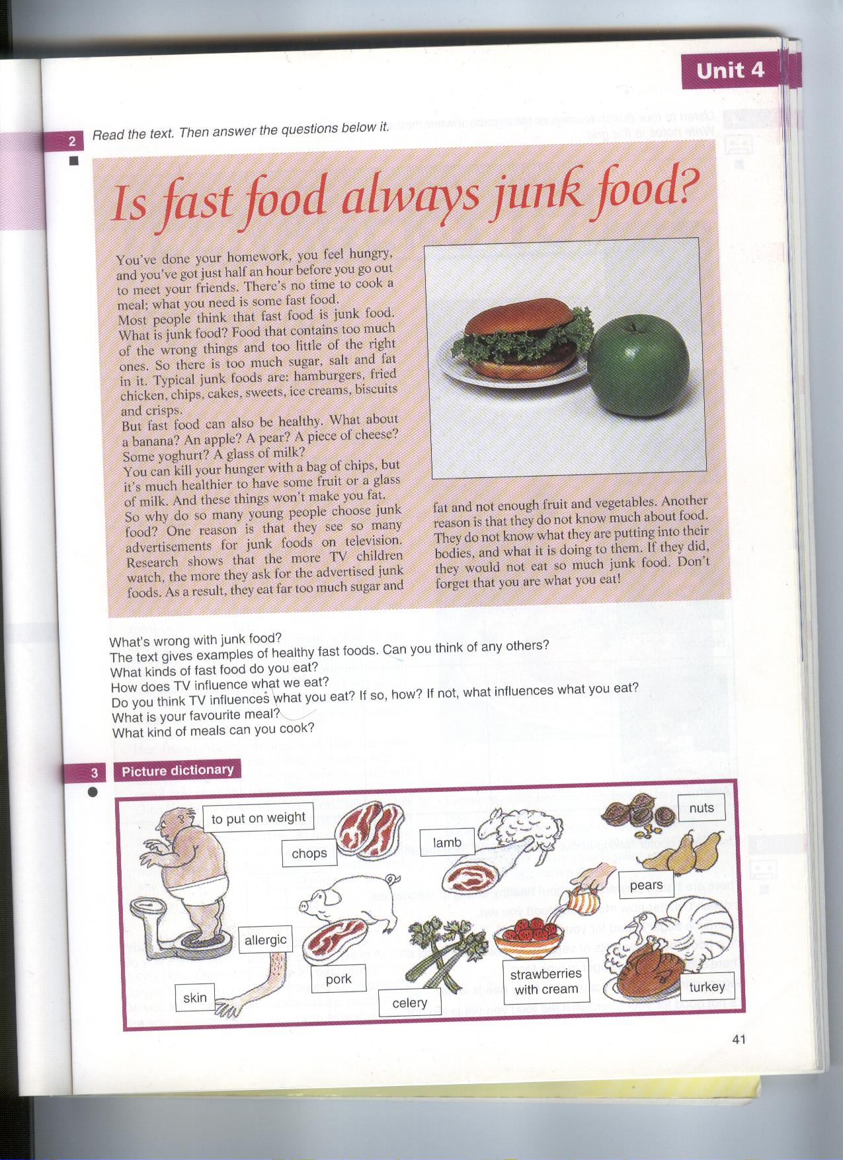
Read the text about fast food and junk food. Then answer the questions below.

You & Me 4th class

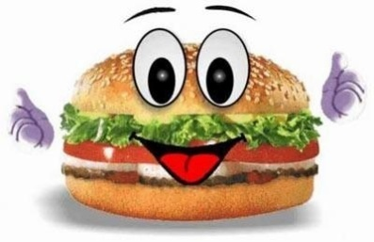
Pre-Viewing Activity
Worksheet
a) In the film “Supersize Me” you will hear a lot of terms you probably don’t know. Some of them are in the list below. Try to find appropriate explanations in dictionaries or with the help of the internet (in English!).
Term | Explanation
Diabetis
Obesity
Nutrition
Overweight
Calory
Diet
Cholesterol
BMI
Nutritionist

b) Word search

f | l | n | f | Q | m | P | o | T | a | t | o | e | s | r | x | j | H | h | s
d | i | s | a | L | a | D | n | F | p | j | w | m | e | r | t | p | U | p | c
e | v | r | f | Y | b | B | u | J | m | d | d | e | b | s | n | o | S | f | h
m | t | t | e | S | k | X | t | C | q | s | a | l | k | h | z | i | U | s | i
k | t | h | j | W | a | L | y | D | q | j | c | e | c | l | r | y | O | m | c
z | f | j | k | H | o | N | n | D | n | z | o | x | r | c | l | s | B | t | k
s | m | e | f | i | u | r | d | B | n | t | u | i | z | u | r | x | W | k | e
d | y | u | s | k | h | s | k | W | a | e | e | n | s | k | c | h | Q | w | n
m | e | x | j | i | a | a | u | S | i | f | l | a | g | w | p | j | K | w | c
p | y | n | i | w | m | u | g | G | e | c | n | j | a | t | v | h | S | k | h
v | t | l | c | k | b | s | i | S | i | a | h | u | g | r | a | p | E | s | i
d | p | y | g | y | u | a | c | Z | n | q | p | e | x | o | g | w | B | l | p
t | g | j | k | n | r | g | h | A | p | e | f | c | s | x | c | q | X | g | s
y | w | l | m | u | g | e | b | V | d | p | o | p | c | o | r | n | J | f | i
k | d | q | c | f | e | s | n | A | e | z | m | a | l | h | t | b | X | v | e
c | a | d | j | e | r | z | n | W | p | s | d | g | a | v | u | u | U | i | l
o | u | o | f | f | s | o | j | O | m | e | a | l | i | n | l | t | O | b | o
f | z | y | z | v | m | k | u | Z | g | e | s | a | i | s | c | t | C | h | k
o | i | h | v | e | i | j | k | V | k | s | r | k | y | q | n | e | F | p | t
l | x | h | l | r | x | h | j | A | h | z | t | p | p | g | n | r | U | w | c

You have to find 15 words.
1) It is bread with cheese or ham and salad.: __________
2) You can eat them at McDonalds.: __________
3) There are bonfires and ________ at Guy Fawkes Night.: _________
4) It is very sweet. You can drink it. : ________
5) You can make chips out of them.: ________
6) You eat it when you go to the cinema.: _______
7) They are sweet, long and yellow.: _______
8) You can eat ____________ legs.: _______
9) The German word for them is "Würstchen".: _______
10) This is what you call "Chips" in German!: ______
11) They are small and green. They are sweet. : ______
12) I like peanut _____________ on my sandwich.: ______
13) In England lots of people eat fish and _______________.: _____
14) Its green and healthy (=gesund). It starts with an 's'.: _____
15) Lunch is a __________, breakfast is a ______________ and dinner is a _______, too.: ____

Supersize Me – The Film
Worksheet

a) When you read the following topics which get discussed in the film what do you expect what they will be about? Discuss it with your partner. Make notes during the film so that you are able to write about it afterwards! Compare what you expected and what it is really about.

- The influence of advertisement and branding on little children.
- Nutrition at school and school cafeterias.
- Do children do less sports activities or exercises than in earlier days?
- What is told about advertising and fast food in the film?

B) Try to fill in the missing words.
Morgan:
EVERYTHING'S BIGGER IN AMERICA

WE'VE GOT THE BIGGEST CARS THE BIGGEST HOUSES, THE BIGGEST COMPANIES, THE BIGGEST FOOD, AND, FINALLY, THE BIGGEST PEOPLE.

AMERICA HAS NOW BECOME THE NATION IN THE WORLD.

CONGRATULATIONS.
NEARLY AMERICANS ARE TODAY EITHER OVERWEIGHT OR OBESE.
THAT'S MORE THAN OF ALL U.S. ADULTS.

SINCE 1980 THE TOTAL NUMBER OF AND AMERICANS HAS , WITH TWICE AS MANY OVERWEIGHT CHILDREN AND THREE TIMES AS MANY OVERWEIGHT ADOLESCENTS.

THE FATTEST STATE IN AMERICA?
WHERE ONE IN FOUR PEOPLE ARE OBESE.

I GREW UP IN WEST VIRGINIA CURRENTLY THE THIRD-FATTEST STATE IN AMERICA.

WHEN I WAS GROWING UP, MY MOTHER COOKED DINNER EVERY SINGLE DAY. ALMOST ALL MY MEMORIES OF HER ARE IN THE KITCHEN.AND WE NEVER ATE OUT, ONLY ON THOSE FEW, RARE SPECIAL OCCASIONS.

TODAY, FAMILIES DO IT ALL THE TIME, AND THEY'RE PAYING FOR IT NOT ONLY WITH THEIR WALLETS, BUT WITH THEIR WAISTLINES.
OBESITY IS NOW SECOND ONLY TO AS A MAJOR CAUSE OF PREVENTABLE DEATH IN AMERICA, WITH MORE THAN DEATHS PER YEAR ASSOCIATED WITH RELATED ILLNESSES.

Post-Viewing Activities
Worksheet

a) In the film “Supersize Me“ were a lot of maybe unknown measuring units. Go to the following homepage (http://www.convert-me.com/en/ ) and answer the questions below.

Masse: one pound = …… kilogram (kg)
Length: one Inch = …… centimetre (cm)
Volume: one Unze …… milliliter (ml)
eine Gallone = …… liter (l)
Energy: one calorie = …… Kilojoule (kJ)

- When Morgan Spurlock began with the experiment he weigh 185,5 pounds. After the experiment 210 pounds. Calculate his body weight before and after the experiment.
- Half a gallon lemonade contains 48 teaspoons sugar. How much litre are half a gallon?
- The nutritionist of Morgan Spurlock said to him that he might not eat more than 2500 calories a day. How much kilojoules are this?

b) In the film they talk about the average amount of calories a person needs a day. Do you know how much you really need?
Go to the following homepage (http://www.medizinauskunft.de/checkup/energiebedarfs_rechner.php) and answer the questions below.

How much calories do you need every day to stay fit and be healthy?
Take your favourite meal from the McDonald’s homepage and calculate how many times you can eat that meal in order to fulfil your average daily amount of calories.

c) Right at the beginning of the film Morgan shows us some pictures of his mother cooking in the kitchen in contrast to pictures with people eating in a fast food restaurant. Discuss the points above with your partner or in groups of 4. Make notes and then write an essay including the questions!

Discussion:
- What do this pictures show us about American’s eating habits?
- Do you think this also fits to the Austrian’s eating habits?
- How often does your family eat a self prepared meal together?
- Do you think that some food to buy is healthier than other?
- Ask your parents what has changed during the last few decades? Is their eating habit today different to the one when they were a child?
- What do you think about the change of eating during the last few generations?

d) Facts about fast food appeared in the film:
Read the facts about fast food. Which do you find surprising? Discuss it with your partner!
- Each day, 1 in 4 Americans visits a fast food restaurant
- In 1972, we spent 3 billion a year on fast food - today we spend more than 110 billion
- McDonald's feeds more than 46 million people a day - more than the entire population of Spain
- French fries are the most eaten vegetable in America
- You would have to walk for seven hours straight to burn off a Super Sized Coke, fry and Big Mac
- In the U.S., we eat more than 1,000,000 animals an hour
- 60 % of all Americans are either overweight or obese
- Left unabated, obesity will surpass smoking as the leading cause of preventable death in America

- Obesity has been linked to: Hypertension, Coronary Heart Disease, Adult Onset Diabetes, Stroke, Gall Bladder Disease, Osteoarthritis, Sleep Apnea, Respiratory Problems, Endometrial, Breast, Prostate and Colon Cancers, Dyslipidemia, steatohepatitis, insulin resistance, breathlessness, Asthma, Hyperuricaemia, reproductive hormone abnormalities, polycystic ovarian syndrome, impaired fertility and lower back pain
- The average child sees 10,000 TV advertisements per year
- Only seven items on McDonald's entire menu contain no sugar
- Willard Scott was the first Ronald McDonald - he was fired for being too fat
- McDonald's distributes more toys per year than Toys-R-Us
- The World Health Organization has declared obesity a global epidemic
- Eating fast food may be dangerous to your health
- McDonald's calls people who eat a lot of their food "Heavy Users"
- McDonald's operates more than 30,000 restaurants in more then 100 countries on 6 continents
- Most nutritionists recommend not eating fast food more than once a month
- 40% of American meals are eaten outside the home
- McDonald's represents 43% of total U.S. fast food market

Summary
Own final statement

As a conclusion try to sum up your thoughts and feelings about the film “Supersize Me”. Therefore, you should write a letter to the boss of Mc Donald’s. Ask him questions you would like to know about the company and write some statements and your opinion about fast food and Mc Donald’s with reference to the film. Use as much facts as you remember and/or like to include into your letter about the film.



III.5 Student’s checklist
Portfolio Checklist
Table of contents
Name: __________________________________________________________________
type | topic | material | with whom? |  | teacher
intro-duction | comment | - personal profile  - expectations
pre- viewing activity | nutrition in general | - word search  - investigation  - term definitions | and
while- viewing activity | „Supersize me“ | - Film script: fill in exercise (missing words)  - critical essay | and
post-viewing activity | fast food | - amount of calories  - discussion topics  - facts about fast food
conclusion | summary: letter writing | - statement and summary

= group work (4 people) = on your own = self-control
= pair work teacher control

Bibliography

Pictures
Front page: http://sanfranciscotutor.files.wordpress.com/2008/12/kids_reading.jpg
Fruit and caterpillar: http://judyoz.com/media/ccp0/prodlg/very-hungry-caterpillar-inside.jpg
Hamburger: http://www.spvgg-rohrbach.de/includes/hppics/hamburger.jpg

Internet and other sources
Cencic, Barbara (2008). Handout PS 5. Graz: University of Graz.
Spurlock, Morgan (2005). Supersize Me DVD.
Supersize Me script: http://www.script-o-rama.com/movie_scripts/s/super-size-me-script-transcript.html
Wegerer (2008). www.wegerer.at

http://www.script-o-rama.com/movie_scripts/s/super-size-me-script-transcript.html

