Methodology of Teaching Literature and Culture
Dr. Elisabeth Pölzleitner

Upper School Project
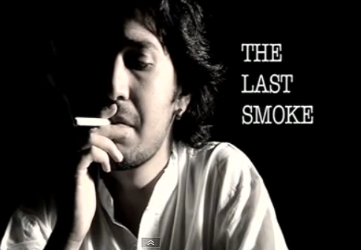

Project handed in by
Sabrina Huber
sabrina.huber@edu.uni-graz.at

“The Last Smoke” – Short Movie for Upper School Students

Form

- 6th form

Pre-knowledge

- inner monologue writing
- stating arguments/giving reasons
- impulse writing

You need…

- enough print-outs of worksheets for all students
- link to YouTube video (http://www.youtube.com/watch?v=OVciAwGqbag)
- projector
- computer
- loudspeakers
- crayons
- paper
- stapler
- homework sheets (can be printed out in A5 to save paper)

Duration of project

- The whole project takes about 90-100 minutes 2 periods
TIME – ROUGH OVERVIEW

Teacher’s Notes
- At the beginning of the lesson students are told that they are going to watch a short film but are not told its themes. They only get to know the film title “The Last Smoke”. In the plenary they discuss what the film could be about. (5 min)
- http://www.youtube.com/watch?v=OVciAwGqbag (3:41 min)
- Start the movie and stop at 1:00. What could have happened to Zaara? Who could she be? (4 min)
- Stop movie at 2:00: Why doesn’t he have a fear of being caught now? Where is he? (4 min)
- Watch the movie again: Students have to look out for symbols (something used for representing something else, e.g. the cigarette stands for…) and make notes/remember those symbols. (4 min)
- Discuss various symbols in the plenary, e.g. the last cigarette represents the man’s last minutes, the knife represents the murder/revenge, putting down the cigarette and extinguishing it stands for the man’s own passing… etc. (5 min)
- There are five different workstations they have to complete (worksheets on five tables). Students get information on workstations:
Workstation 1 | Students think about the statements concerning death penalty and find a partner they can discuss them with. | 10 min
Workstation 2 | Sheet with pictures of the two characters. Students fill in the missing information. | 8 min
Workstation 3 | Students have to write an inner monologue from Zaara’s perspective at the end of the film. | 10 min
Workstation 4 | The film becomes a book. Students have to find a title that is different to the film, create a cover and write down the plot. They have to be provided with crayons. | 15-20 min
Workstation 5 | Students have to put themselves into the role of one of the characters. | 10 min
- The whole workshop does not fit in one lesson so it has to be continued in the following lesson. A few minutes before the bell rings, they get homework sheet 1 (internet research).
- In the second lesson the results of their internet research are compared and discussed with the whole class. (10 min)
- The short film is shown again for those who were not here the lesson before and to refresh students’ memories (so it is easier to complete their worksheet tasks). (4 min)
- When the students are done with the workshop tasks, they staple their sheets, write their names on the first page and hand in their small projects. Homework sheet 2 is handed out.
(rest of the 2nd lesson)
Think about the following statements and find a partner to discuss them with.
Do you agree or disagree with these statements? Give reasons.

The death penalty should be abolished.

‘Two wrongs don’t make a right’. Someone who inflicts the death penalty is as bad as the criminal.

The death penalty should only be used in case of murder.
The death penalty can never be justified.

‘An eye for an eye, a tooth for a tooth.’ If someone kills another person, they deserve to die.

If the wrong sentence is passed in a case, the death penalty cannot be reversed.
Paedophiles and rapists deserve the death penalty.
The death penalty makes good economic sense – at the moment the taxpayer has to pay to keep criminals in prison.

The death penalty is a good way of reducing crime levels.
The death penalty is the height of cruelty.

Fill in the missing information. Who could they have been?

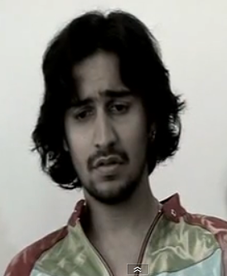
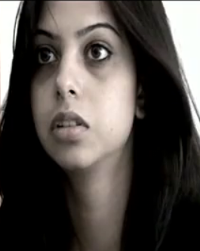

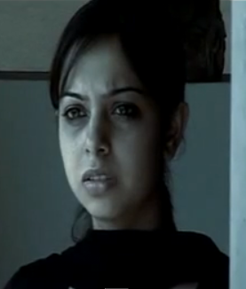

Write an inner monologue from Zaara’s perspective at the end of the film. What is she feeling/thinking?

The film becomes a book. Design a cover and find another title.
Write down the plot of the book in about 80-100 words.


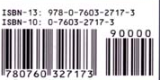

Put Yourself in Someone Else’s Shoes
Do you always agree with the decisions made or actions taken by characters in the film? Think of a time you did not agree with a character. In the shoe on the left, write about the situation and what the character did. In the shoe on the right, write about what you would have done if you were the character. Why would you have done things another way?
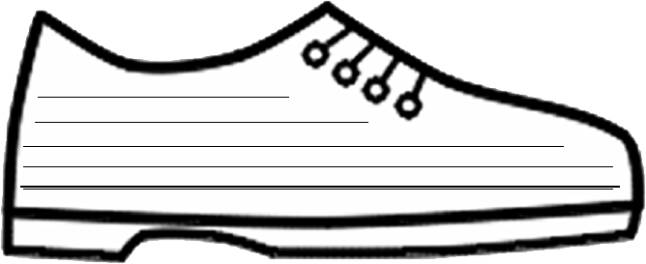

Homework Sheet 1

Internet research
Try to find out the following information:

  - Is Europe a death penalty free area?

  - When and how was the last person executed in Austria?

  - Are there more men or more women on death row? Find statistics.

  - In which country do most executions take place?

  - Which method of execution is most common today?

Homework Sheet 2

Writing task

Choose one of the following tasks and write at least 200 words:

- Write a different ending to the short film. In what other way could it have ended?
  - Write from the narrator’s perspective.

- Picture impulse

  - What does the following picture mean to you? Put your thoughts in words and think of what we have discussed in today’s lesson.

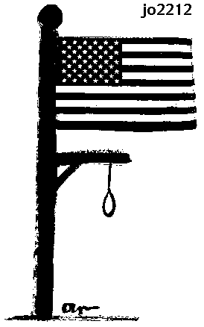

Argumentative essay: “Is the death penalty an effective crime deterrent?”

  - Use arguments from workstation 1 as well as some you come up with on your own.
  - Keep in mind the following five steps:
1. Plan
2. Outline
3. Write
4. Edit
5. Rewrite

Adapted from „Super-Fun Reading and Writing Skill Builders” Scholastic Professional Books

