My Interests: BINGO

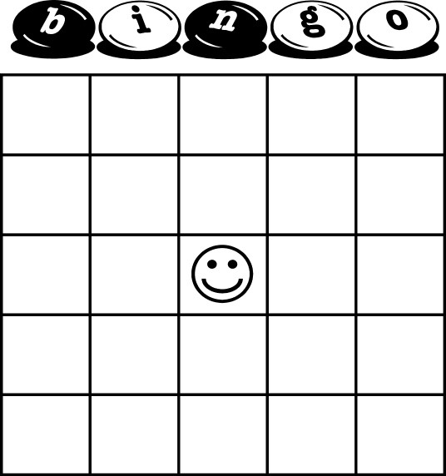

My Interests: BINGO

