grouping
http://edpd593finalproject.weebly.com/flexible-groupings.html

Ann Tomlinson film
https://www.youtube.com/watch?v=Q6yptrEJl9M

https://www.google.at/search?q=youtube+ann+tomlinson&oq=youtube+ann+tomlinson&aqs=chrome..69i57j0j69i60j69i64.3552j0j7&sourceid=chrome&ie=UTF-8

https://buildingrti.utexas.org/

goals and objectives: http://www.personal.psu.edu/bxb11/Objectives/GoalsAndObjectives_print.html
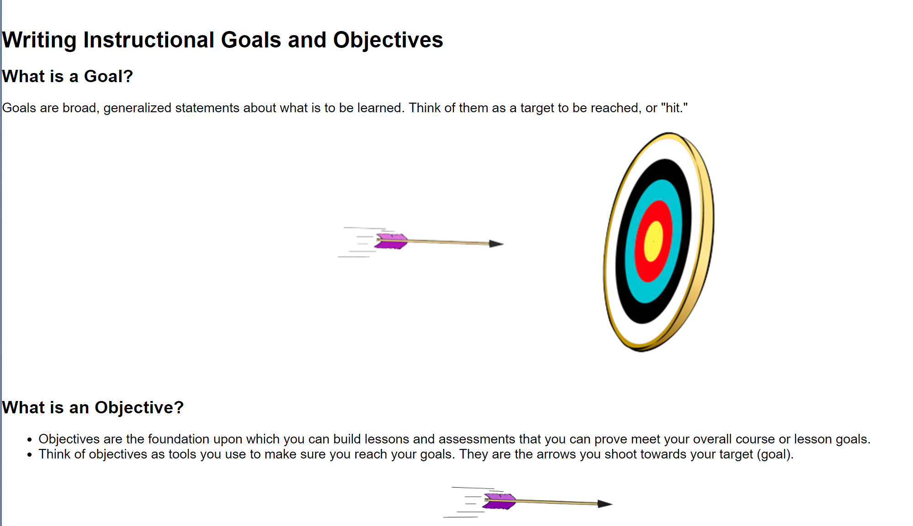

Beobachtungsaufgaben für das PPS2: Differenzierung und Inklusion
Classroom Observation Form nach Tomlinson: https://www.cosa.k12.or.us/downloads/profdev/Tomlinson/DI%20Obs%20Form--Permission.pdf
Differentiated Instruction Observation Look-Fors (Tomlinson)
http://www.bsd2.org/DocumentCenter/View/4038
Differentiated Instruction Checklist (Univ. of Texas)
https://buildingrti.utexas.org/sites/default/files/documents/DiffInstrChecklist.pdf

Supper ppt that covers all the important steps, combines well with Tomlinson
http://steinhardt.nyu.edu/scmsAdmin/uploads/006/188/8-27,%20James%20Bao.pdf

Reproducibles from Tomlinson/Sousa
https://www.solutiontree.com/free-resources/instruction/dab

Geoff Petty (Sarah’s tip) http://geoffpetty.com/

