PPS2-  WS17-18 | Topics:  Topics that I have planned for this semester. Depending on your interests and issues that arise in your teaching placement, we might make some changes. | Homework: Find detailed instructions for all assignments on Moodle  We will make up the time of the cancelled sessions by working a bit longer every week.  As discussed in class we will start at  15.00 and work till 16.45 | Pack
1  3.10. | In a Nutshell….  Course overview and assessment  Course Resources and Dialectical Journal  Unique Minds and Learning Differences: Brainstorming  Jigsaw activity: DiA, chapter 1 | A1: Revise and complete your mindmap  A2: Read “What Differentiated Instruction Is and Isn’t” and write an entry into your dialectical journal.  Order your textbook: Differentiation in Action (J. Dodge) | for activity 3  unique minds --chapter 1 copies DiA  (5x)
10.10. | cancelled | Start working on your class observations. Use the observation sheets in the Practicum brochure. Do 3 different observations by December 12th.
2  17.10 | Catering for the needs of all learners  The Nonnegotiables of Differentiated Instruction  Groupwork: The Tomlinson Model (Choiceboard) | A3: polish your version of the Tomlinson model  A4: Read chapter 2 in DiA and do the tasks in the study guide. | padlet QR codes  questions….
24.10. | cancelled
3  31.10. | Building competence: How does learning work?  Meaning and Sense: “Two Essentials for Durable Learning”  What teachers need to know about the human brain. | A5: Read chapter 3 in DiA and read or watch at least one of the articles or videos from the Symbaloo choiceboard provided on moodle.  Then select one of the “choice homework options” on page 54 of DiA. Upload your work to moodle. | Padlet QR competences  Sense-and Meaning copies 12x (in my file- pps2-my-prep)  Brain ppt on stick
4  7.11. | The importance of choice  1.Share your choice homework in groups and present the best ideas in the plenary.  2. Teacher input:  - Free homework  - Magazines  - gibsters.com  - readingiscool  3. Create choice homework options for one of your classes  4. Present your ideas in the plenary | A6: Complete and polish the choice board that you have started in class. Use pp 67-68 to help you.  A7: Bring at least one good lesson plan that you have created in your practicum and be prepared to present it in class. Have your materials ready (on paper or your tablet or laptop to show in a group and on a USB stick or online to present it on the projector. We will be working with your lesson plan in class.
5  14.11. | Bloom’s levels of complexity  - A short video  - What’s on your mind? (Today’s meet)  - 3. In groups: Analyze your lesson plans according to Bloom’s taxonomy.  Then improve your lesson plan by adding activities at different levels of complexity. | A8: Complete and polish one of your lesson plans by adding activities at three levels of complexity. Upload your revised lesson plan to moodle. Indicate the levels of complexity clearly.  A9: Read chapter 5 in DiA: Answer the "How I am Smart" questions on p. 94 for yourself to find out your preferred intelligences. Then create a set of four "Gardner in Bloom Activities" (like p.99) for a topic that is relevant for one of your practicum classes.
21.11 | cancelled | A10: Write an entry in your dialectical journal. Reflect upon the topics choice and Bloom’s complexity levels.  What are your experiences and opinions about this?
6  28.11.  . | Multiple Intelligences  Sharing Gardner in Bloom activities with the class  More examples  - booklets (blank sheet)  - creative book presentations  - genius hour | A11: Read chapter 6 in DiA and prepare a "cheat-sheet" for yourself. Chapter 6 is about organizing flexible groups in the classroom. Collect lots of ideas for breaking up the traditional teacher-directed classroom. Describe each one in just a few words. Choose any format that suits you: a list, a table, a diagram, a mindmap... Only include ideas that you would like to try in your future teaching. If an idea does not appeal to you at all, leave it out.  Read pages 199-223 in Jim Scrivener, Classroom Management Techniques and add the ideas to your "cheat-sheet".  Be prepared to present your collection in class next week. | first share in groups, then each group presents at least one set of GiB activities.
7  5.12. | Flexible Groupings  - Classroom arrangements  - Useful tools for flexible groupings  - Groups create a poster  - Gallery Walks | A12: Read chapter 7 in DiA and take notes in your dialectical journal.  A13: Upload your three classroom observation sheets to Moodle. We will work with them in class next week.
8  12.12. | Readiness: Tiering Lessons  and teaching for different age groups  - Today’s Meet  - Plenary discussion  - Design materials for a tieredactivity  - Gallery Walks | A14: Finish and polish your tiered lesson materials and upload them to Moodle.  A15: Watch some of the videos on classroom management and/or (re)read chapter 6 in Jim Scrivener, Classroom Management Techniques.  Write an entry in your dialectical journal. Collect lots of ideas in column 1 and reflect on them in column 2.
9  9.01. | Classroom Management and Discipline  - Sharing our findings  - Create a discipline toolbox  - Dealing with tricky situations | A16: Choose one or two differentiated activities that you are proud of. Plan your presentation well and use lots of visuals and media to get your message across. You have about 5 minutes to present your materials + 5 minutes discussion time after each presentation.
10  16.1. | Creating a DI Toolbox  In the last three sessions we will be sharing and presenting good materials, tasks and lesson plans for differentiated learning. Each student will have to present their highlights so you all leave this course with lots of good ideas for reaching all learners. | presentations continued
11  23.1. | Creating a DI Toolbox | presentations…
12  30.1. | Creating a DI Toolbox: tying up loose ends




Materials for Session 2:
QR codes
Some color pencils, markers, felt tip pens

Padlet: questions are more important than words, PPS2, section 2


Padlet for Associations with the term COMPETENCES

 | 

x

Carol Ann Atomlinson, The Differentiated Classroom, ASCD, 2014, p. 63 -64
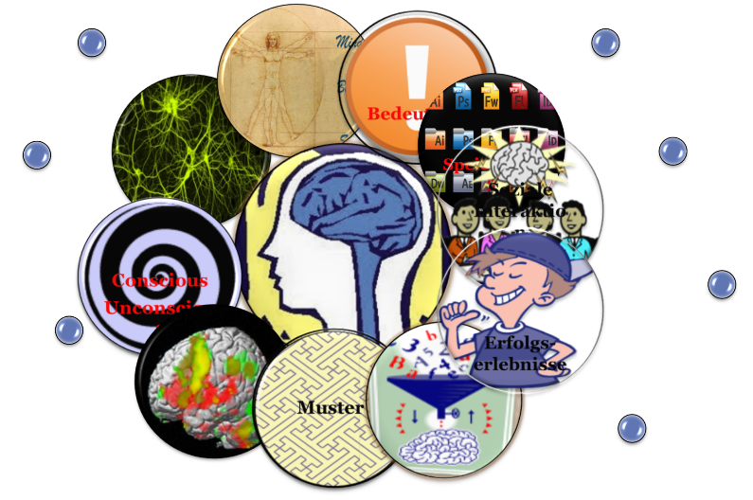 | 
For Exit Cards:
Todaysmeet
http://today.io/1sQQR

Today’s Meet: for Exit Cards:
www.todaysmeet.com
username: email
pw: m
go to the room PPS2-WS-2017 – then click on the MORE dots on the right, open projector view!!!

