Button Characters

Buttons have lots of qualities that help define characters. They are old or new, they are large or small, they are made of plastic, glass, wood, metal, they have a smooth or rough texture, they may be shiny or dull, translucent or opaque. They have bright colors or dark colors. All these qualities can be linked to story characters.
Task: Choose a button from your teacher’s collection (or the picture below) and describe it in detail. What do you see? What does it feel like? What does it remind you of? Who might have worn it? Where has it been? The button then becomes a character with a name, an age, a profession, likes and dislikes...It has a whole life of its own. Make notes of all the things that you “know” about this character.
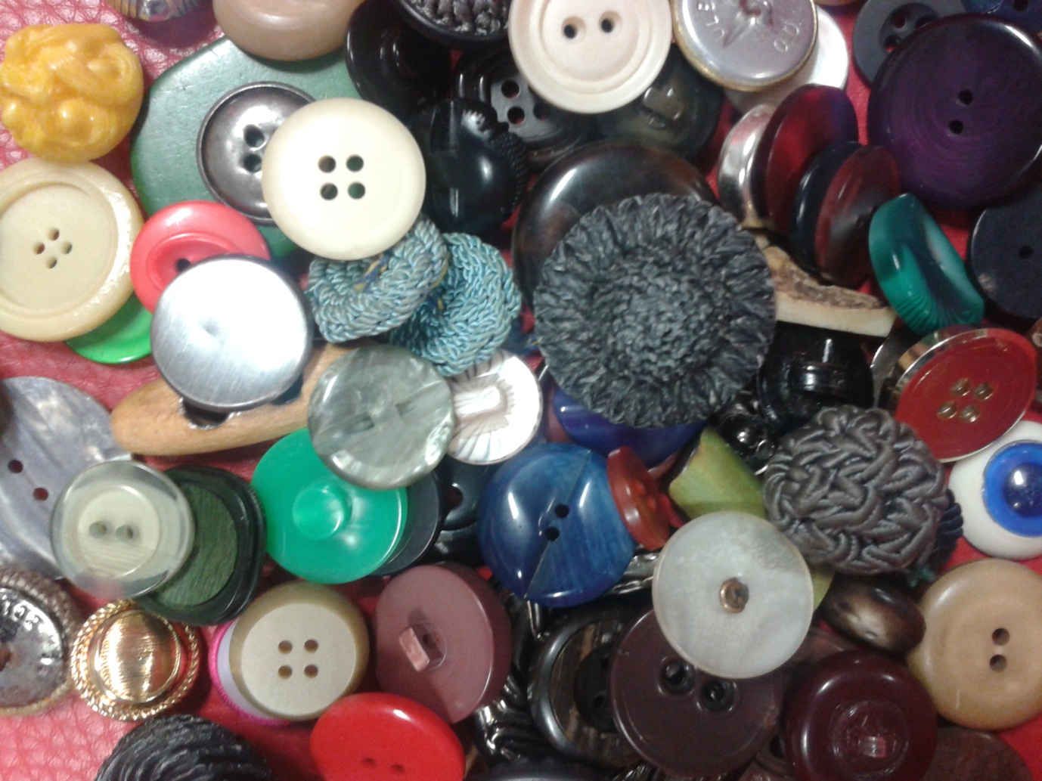

Meet with 3 other students. Present your characters to each other and imagine that your characters are meeting in a story.
- Where does this meeting take place?
- What are the circumstances?
- What roles do the characters play? Who are they?
- How do they behave?
Plan the story:
Make up a plausible story. Use the story planning sheet to plan all the important aspects of your story.

Homework:
Write a first draft of the story based on your group’s plan and bring it to class on …………………………

Peer Conferencing:
Share your stories in your group and help each other improve them. What can you learn from the other stories in your group? How have your fellow students used the story plan? Include some of the good ideas or expressions in your own story and polish it up at home. Hand in your revised story by ……………………………….

