.
Spooky Story Game  Play this game in pairs or groups of three. Put the picture cards on a pile and lay all the text cards out on your desk.  Start with the first picture card. Describe the scene in as much detail as possible. What do you see? What do you hear? How many of the text cards can you use? Add as many details as possible.  What might happen next? Add one or two events. | Spooky Story Game  Play this game in pairs or groups of three. Put the picture cards on a pile and lay all the text cards out on your desk.  Start with the first picture card. Describe the scene in as much detail as possible. What do you see? What do you hear? How many of the text cards can you use? Add as many details as possible.  What might happen next? Add one or two events.
Spooky Story Game  Play this game in pairs or groups of three. Put the picture cards on a pile and lay all the text cards out on your desk.  Start with the first picture card. Describe the scene in as much detail as possible. What do you see? What do you hear? How many of the text cards can you use? Add as many details as possible.  What might happen next? Add one or two events. | Spooky Story Game  Play this game in pairs or groups of three. Put the picture cards on a pile and lay all the text cards out on your desk.  Start with the first picture card. Describe the scene in as much detail as possible. What do you see? What do you hear? How many of the text cards can you use? Add as many details as possible.  What might happen next? Add one or two events.

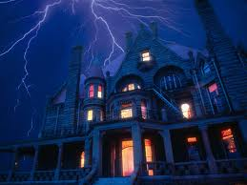  1http://gurneegraded56.sharpschool.com/UserFiles/Servers/Server_2464887/Image/Mr.%20Butler/spooky-house-with-lightening.jpg | 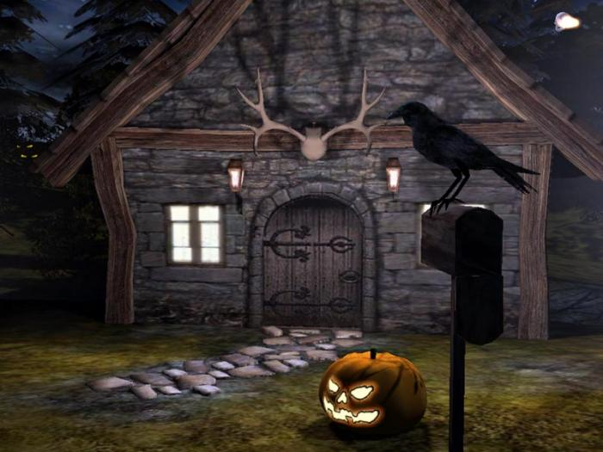  2http://sandbox.yoyogames.com/extras/image/name/san2/212/335212/original/SA0...jpg
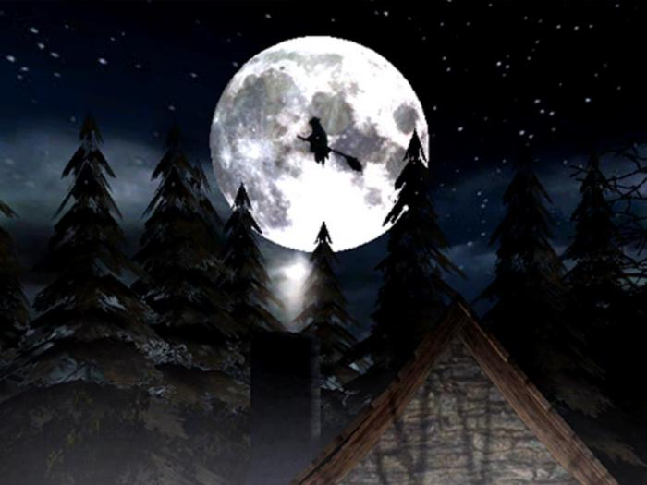  3http://screenshots.de.sftcdn.net/de/scrn/55000/55380/3d-spooky-halloween-screensaver-2.jpg | 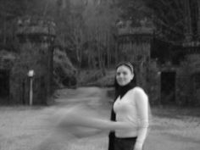  4http://media-cache-ak0.pinimg.com/originals/7e/a2/9e/7ea29e14c98c799e93526dd0192b7f99.jpg
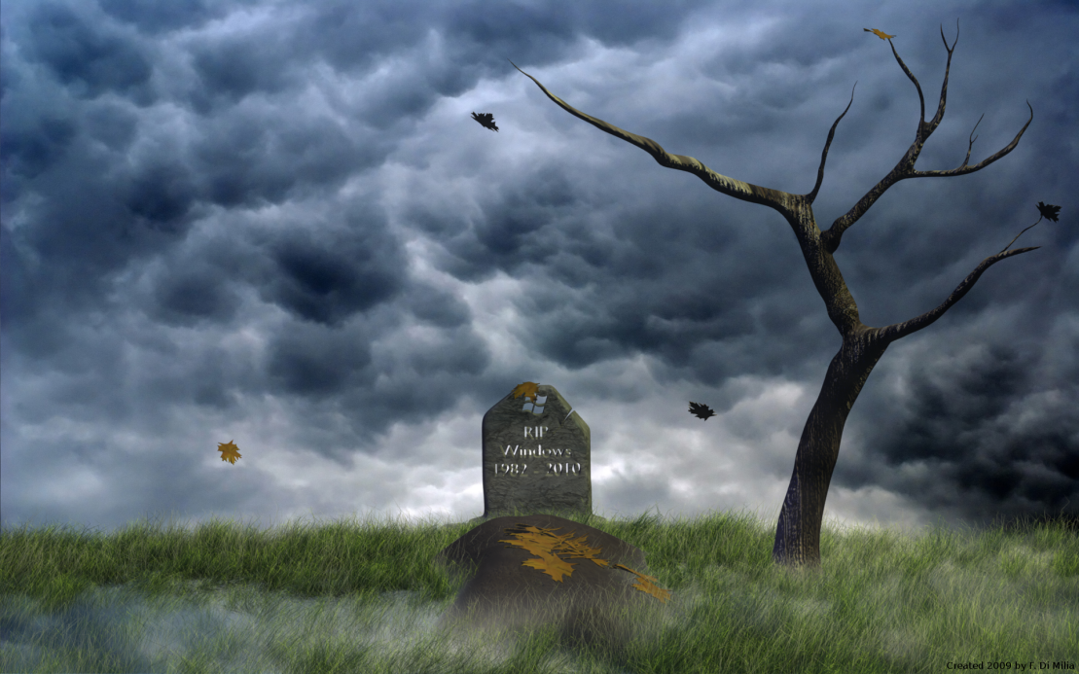  5http://www.desktopas.com/files/2013/10/Spooky-Halloween-2-Wallpaper-1920-x-1200.png | 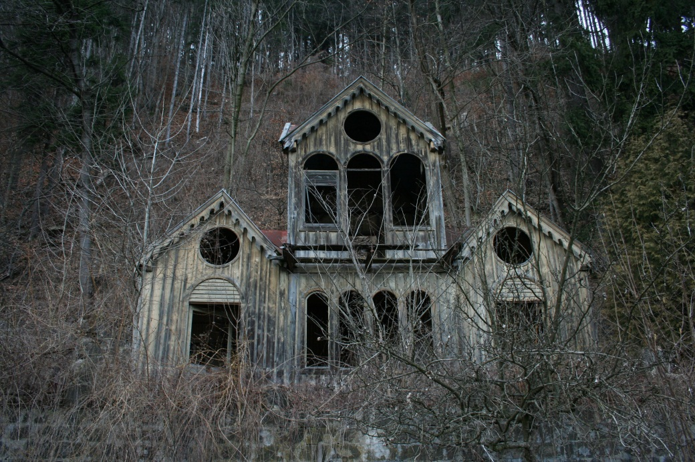  6http://www.hdwallpapersfree1080p.com/wp-content/uploads/2013/10/spooky_house_01_by_chulii_stock.jpg
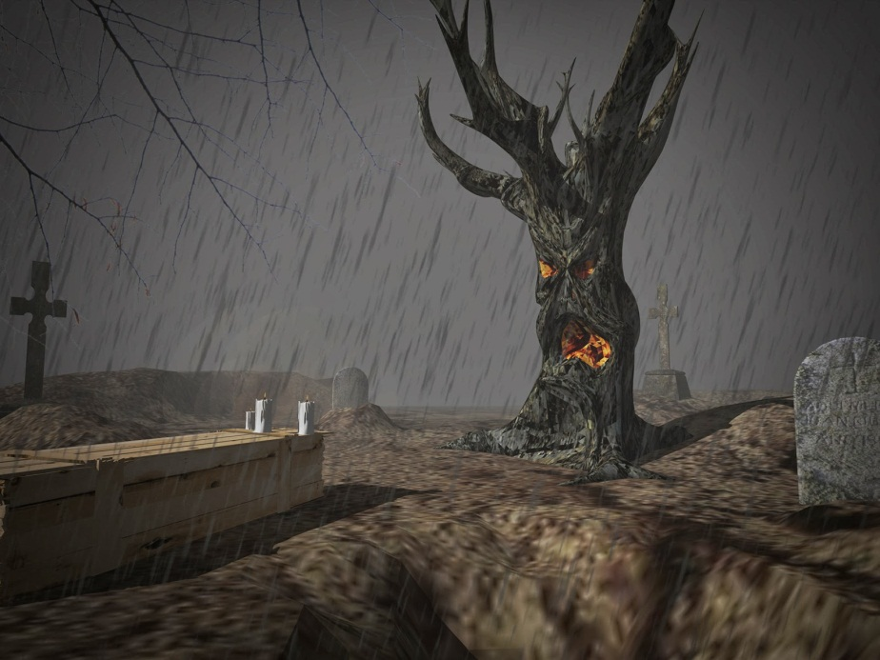  7http://2.bp.blogspot.com/-Ew3HRTMZW1o/UnQpQZXgbaI/AAAAAAAABlo/fVYhy6_LHDk/s1600/190_alsomar.jpg | 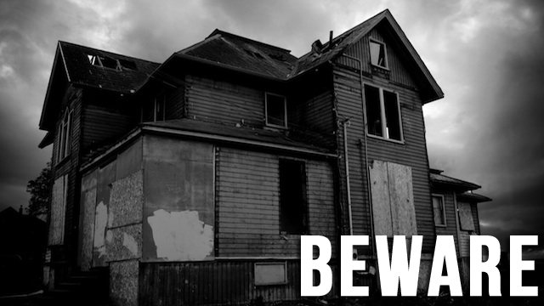  8http://jezebel.com/5854965/ten-super+spooky-ghost-stories-to-keep-you-awake-tonight
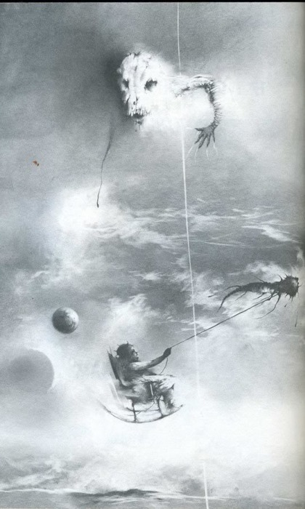  9http://imageshack.us/a/img823/4435/ie60.jpg | 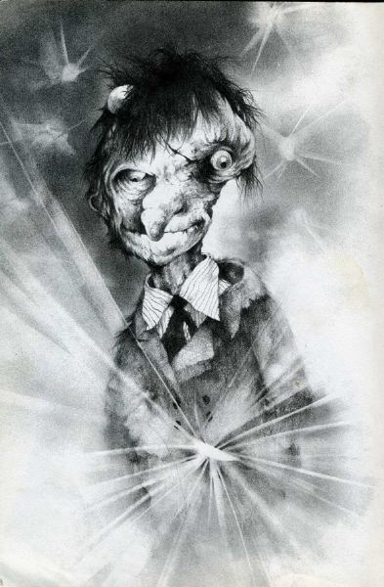  10http://img443.imageshack.us/img443/3582/sc32vz0.jpg
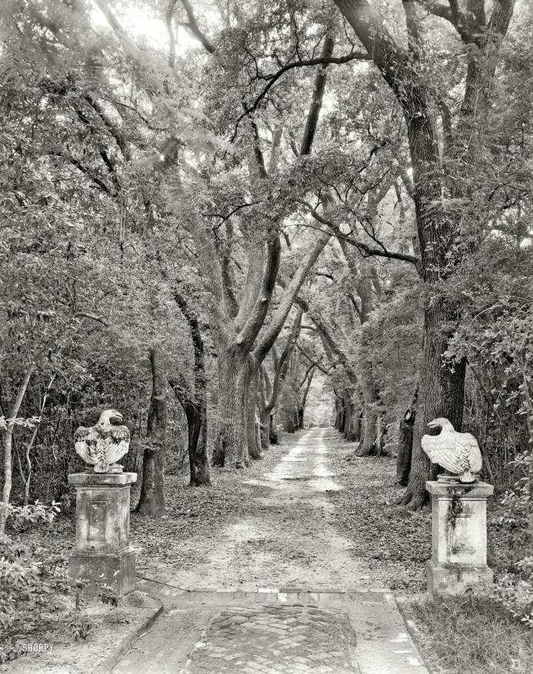  11http://3.bp.blogspot.com/-k49tqOzGq5I/Tq08Ks1NsiI/AAAAAAAAAuQ/w-iRtwKfMys/s1600/spooky+path+1939.jpg | 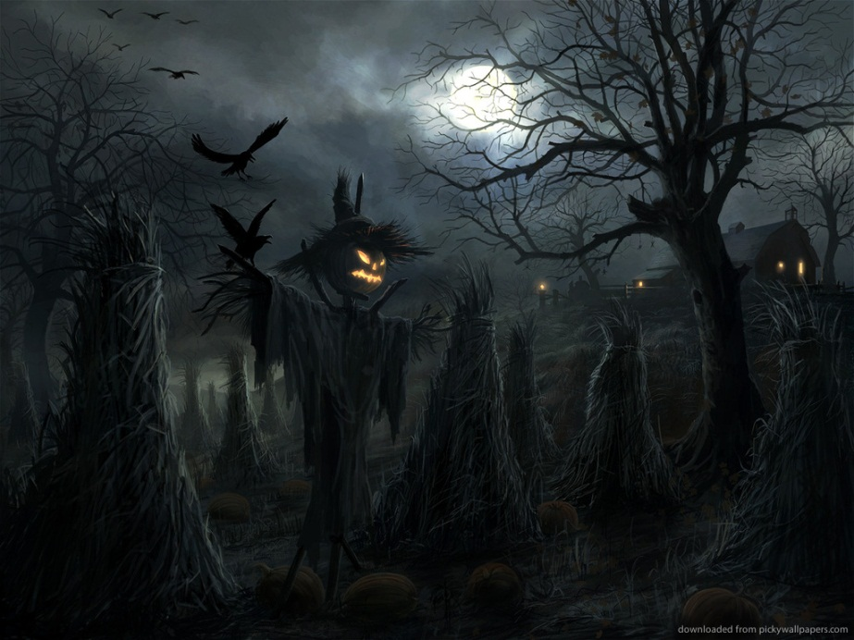  12http://smilingthroughtearz.com/wp-content/uploads/2013/09/spooky-halloween-landscape.jpg

Suddenly….I saw// I heard// I felt… | All of a sudden… | The moon was shining. | There were whispering sounds.
A storm was howling. | Thunder was rumbling in the distance. | Smoke was rising out of the chimney. | The door was ajar.
It sounded like the wind was whispering a secret into my ear. | Far off in the distance a wolf was howling. | The weeds/bushes were rustling in the garden. | Lightning was flashing through the sky.
The wind/rain was lashing against the door. | An owl was hooting somewhere in the darkness. | The shutters on the windows were swinging/banging open and closed. | Shadows were dancing across the garden.
The moon was casting shadows across the garden. | Clouds were blanketing the sky. | The moon was shining and clouds were blowing across the sky. | It was dusk and the sun was setting in the sky.
The children were tiptoeing through the garden. | One boy/girl was looking/peering through the gate. | One boy/girl was whispering into the other one’s ear. | They were shaking with fear…
They were trembling with fear… | His/her voice was trembling. | The gate was creaking in the wind. | The wind was whispering through the trees.
The overgrown grass was blowing in the wind. | The animals were hiding in their holes. | Spiders were spinning their webs. | The crows were shrieking.
A candle was flickering in the window. | The jack-o-lantern was glowing | The windows were boarded up. | The wind was moaning in the distance.
The statues were staring down at them. | The fire was crackling in the fireplace. | The spider webs were swaying in the breeze. | The floorboards were creaking under their feet.
Dark clouds were rolling across the sky. | Frogs were croaking near the pond. | The sound of footsteps was echoing through the house. | Bones were rotting in the front yard.
Her teeth were chattering uncontrollably. | Ravens were flying through the sky. | A rocking chair was creaking in a corner. | The wet grass was glistening in the moonlight

