Peer Editing Form: Essay

Peer editor's name: Title of paper:

Title:  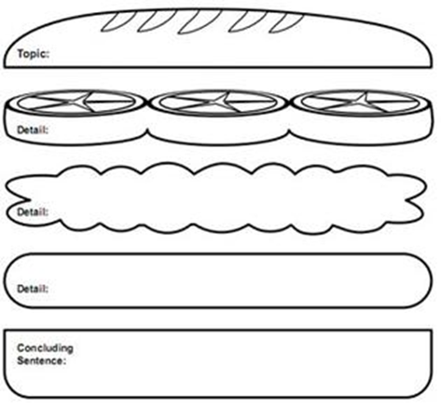  Use the back of this sheet for further comments and tips. | Is my title clear and telling? How could I improve it?
 | Is my introduction clear and interesting? What could I do to show the relevance of the topic more clearly?
Can you find my thesis statement? Is it clear and convincing?
Does it contain all the main arguments? What is missing? What should I add?
Does my 2nd paragraph start with a topic sentence?
Does the paragraph stick to ONE topic or does it digress? Are my examples and arguments valid and clear?
Have I used appropriate link-words?
Does my 3rd paragraph start with a topic sentence?
Does the paragraph stick to ONE topic or does it digress? Are my examples and arguments valid and clear?
What can I do to make them more convincing?
Does my 4th paragraph start with a topic sentence?
Does the paragraph stick to ONE topic or does it digress? Are my examples and arguments valid and clear?
What can I do to make them more convincing?
Conclusion: Is my conclusion convincing? Does it restate my main arguments clearly?
Have I managed to convince YOU?
What else could I do to get my message across even more clearly?
Range of Vocab and Grammar:
Can you suggest any phrases that will make my essay sound more professional and idiomatic?
Have I used neutral or formal language?
Can you find any contractions or colloquial terms that need to be replaced?
 | Accuracy: Can you find and correct any language mistakes?

