Writing a REPORT

What is the purpose of a report?
Usually a report
- gives information
- evaluates something
- or makes suggestions and recommendations

Who will read it?
In most cases the report will be requested by somebody in authority, like a boss or a principal. Often they will want to read the report to gain information in order to make a decision based on facts.

What style should you use?
Be very clear. Give essential information and recommendations.
Use an impersonal style, avoid the personal pronouns 'I' and 'you'.
A report is NOT a letter. Do not use letter openings and endings.
Be concise and precise: do not repeat yourself; make every word work for you.
Do not lift whole chunks of language from the rubric: reword it.

How should I structure a report?
Heading: clear, factual and precise
Introduction: purpose of the report, who is it intended for?
Body: sections with sub-headings dealing with the separate aspects of the subject
Recommendations and Conclusion: This can be one or two paragraphs, depending on the overall length of the report.

Important Points when Writing Reports:
When writing a report as a school assignment
- read the task very carefully
- highlight all the given information which has to be included
- decide what you have to add to make your report as authentic as possible
- be creative, specific, plausible and coherent when making up details. Think yourself into the situation. Give specific evidence to explain and exemplify your main points. You might for example talk about a survey or interviews that have been conducted.
- Use the bullet points given to structure your report (headings!) and include a brief introduction and conclusion

Declaration of Independence for Writers of Reports

I, ______________________, solemnly promise that when I venture out into the big wide ____________ and am asked to write a ____________, I shall write ___________ what I have been _____________ to write. I understand that when I write a _________ , I shall be ___________ an important service at somebody's _____________ , almost certainly a person in a higher ____________ or a position of _______________ .

Furthermore, should I be writing _________________ of a person or persons who are depending on me to represent them, I shall do my _______________ to present their case in an accurate and _____________ report. Then, and only then, shall I reveal that I _______________ GIBS and had _______________ as my English teacher.

Useful phrases for writing reports

Introduction and stating aims:
The aim of this report is to …
This report is intended to...
This report intends to / aims at...
This report will consider /examine/ compare....
This report looks at ….
In order to prepare this report, ...was/were visited/ interviewed/ studied... (Use passives here.)
on behalf of...
at the request of...

Reporting impressions and findings:
It seems / appears that...
Most people / the majority of people seem to /tend to …
It is interesting/ surprising / strange that...
Interestingly, Surprisingly, Strangely,
A survey/ study conducted by... has shown that...

Quoting:
According to X, Y said / felt/ mentioned that … + reporting tenses!!!

Giving reasons:
Since /As (our city is well-known,...-
For this reason / these reasons.
Consequently,

Generalizing
In general,...
On the whole,...

Summing up:
In conclusion,...
To sum up,...
In short,...
To summarize,...

Making suggestions or recommendations
In my opinion /view
I would recommend (doing sth)
In view of this, I (would) recommend / suggest (that)
We/ I (would) suggest (that)...
They / We could
It is recommended that...
Our recommendation /suggestion is to...

Practice Activities:

1. Organizing a recommendation report
The first paragraph of this recommendation report is missing. Read the report, then choose the most appropriate first paragraph from the three given.

Proposed Subscription to a British Newspaper
1st paragraph is missing. Choose a, b or c below.
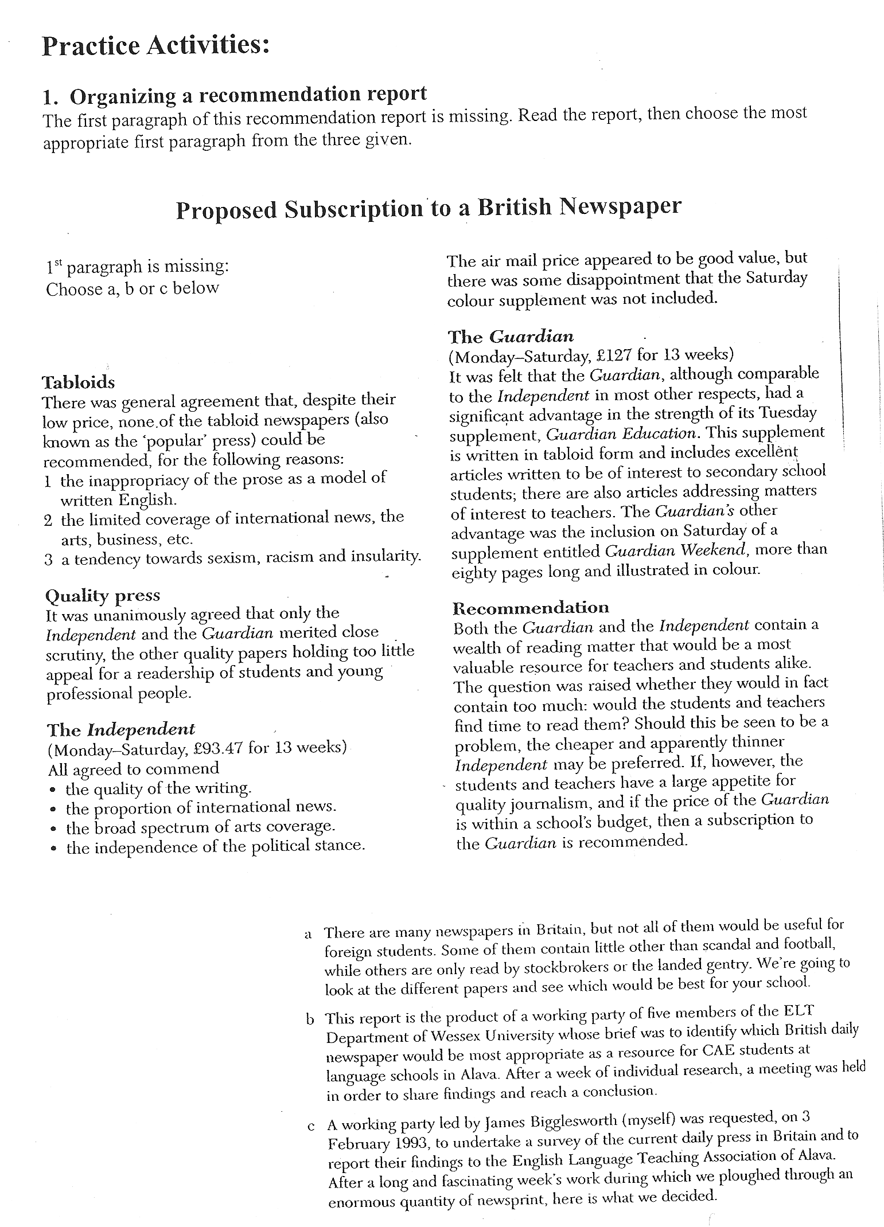
Report on Need for Financial Support for Victoria Village School
Use the plan and vocabulary given to write a report for Ms Price of Price Right Electronics.

You are spending a gap year in Lesotho, working as a voluntary English teacher in a village school. On behalf of the school, you have applied to Ms Price, as manageress, for sponsorship. Before she decides to donate, Ms Price wants to know how her money will be used.
Write a report for Ms Price explaining
- what conditions are like in the school
- what the school most urgently needs money for
- how she/ner firm can benefit from becoming a sponsor
Write 220 words (+/- 10%)
Report on Need for Financial Support for Victoria Village School

Introduction
_________________ Ms Price, executive director of Price Right Electronics, this report ________________ the conditions in Victoria Village School, Lesotho, ________________ donations made to the school might be __________________ and ____________________ sponsors could benefit from supporting Victoria Village School.

Conditions in Victoria Village School
(faulty toilets, overcrowded classrooms, outdated teaching materials)

Proposed use of donations
(repair to sanitary facilities, extension: extra classroom, new textbooks for English)

Benefits for sponsors
(BBC documentary on Victoria County planned > media attention)

Conclusion:
As the main center of elementary education in Victoria County, a developing area in Lesotho,j Victoria Village School must __________________ adequate schooling for all children. Funds are __________________ to provide basic _________________ for learning, health and well-being as the state allowance for village schools is ______________ . Sponsorship will be __________________ and acknowledged.

Useful Vocabulary:

currently/ at present / at the moment

in poor /bad condition
in a critical/ dangerous condition
in a poor /bad /critical state of repair
in urgent need of renovation /refurbishment

a severe lack /shortage of (adequate) facilities / teaching materials / equipment/ furniture

sanitary facilities / roof repairs are urgently required
additional space is needed to accommodate the growing numbers of students

to attend school

improvements / repairs / and extension TO (e.g. the school building / the premises)

financial aid / support is (most) urgently needed to / for (e.g. repairs of the roof)
donation would be used to / for

At the request of Ms Price / the town council / the principal, this report …
In return for sponsorship / the valued support of Price Right Electronics, we can offer / we would be pleased to / we would be happy to …

advertising space can be made available

media presence / interest / attention / coverage is guaranteed

