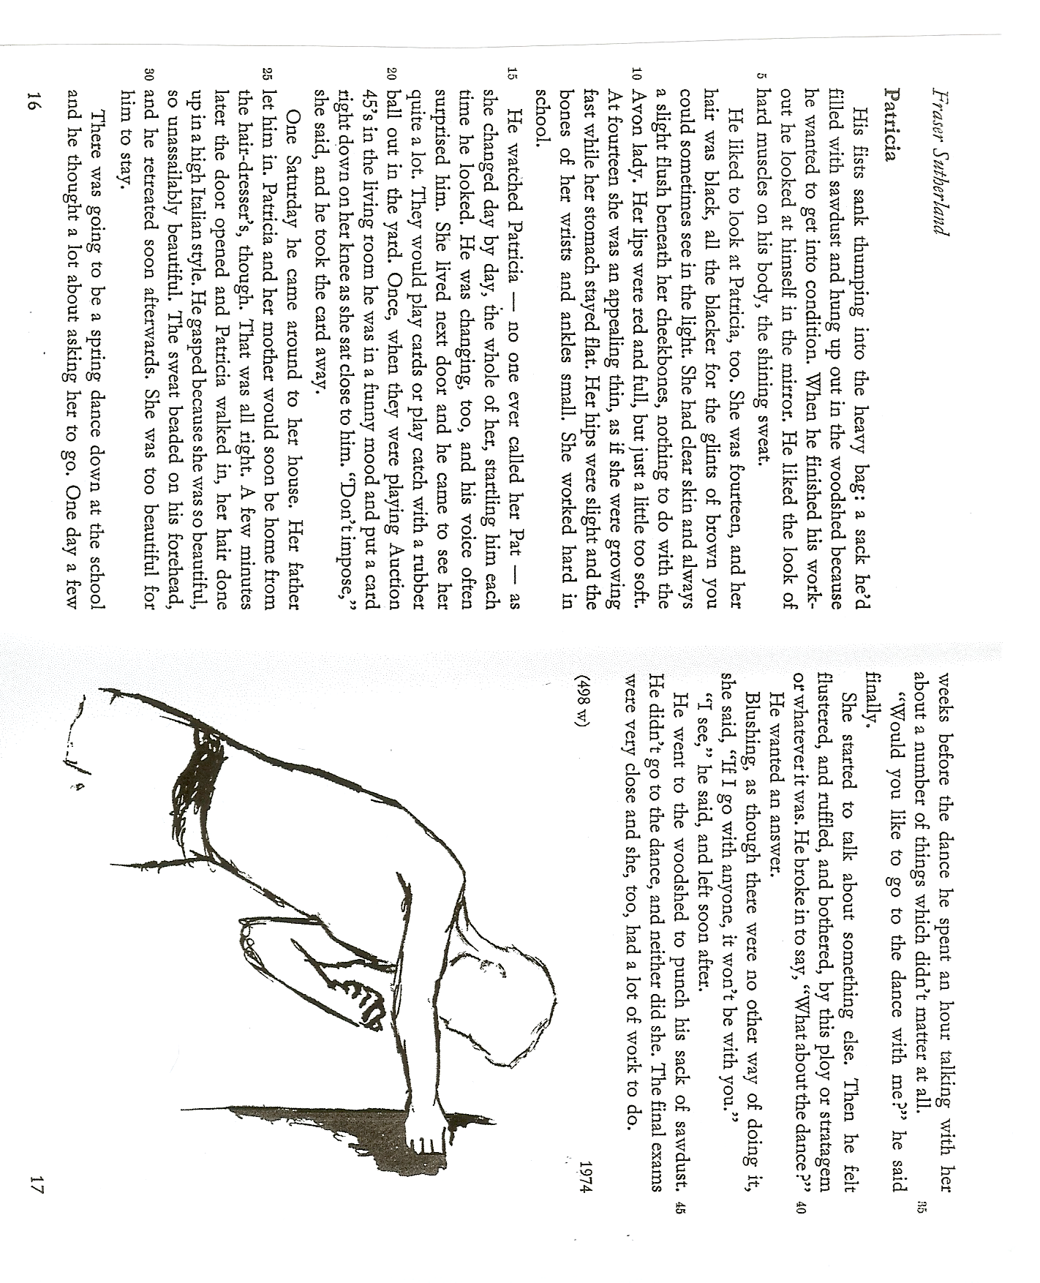
What is a Short Story?

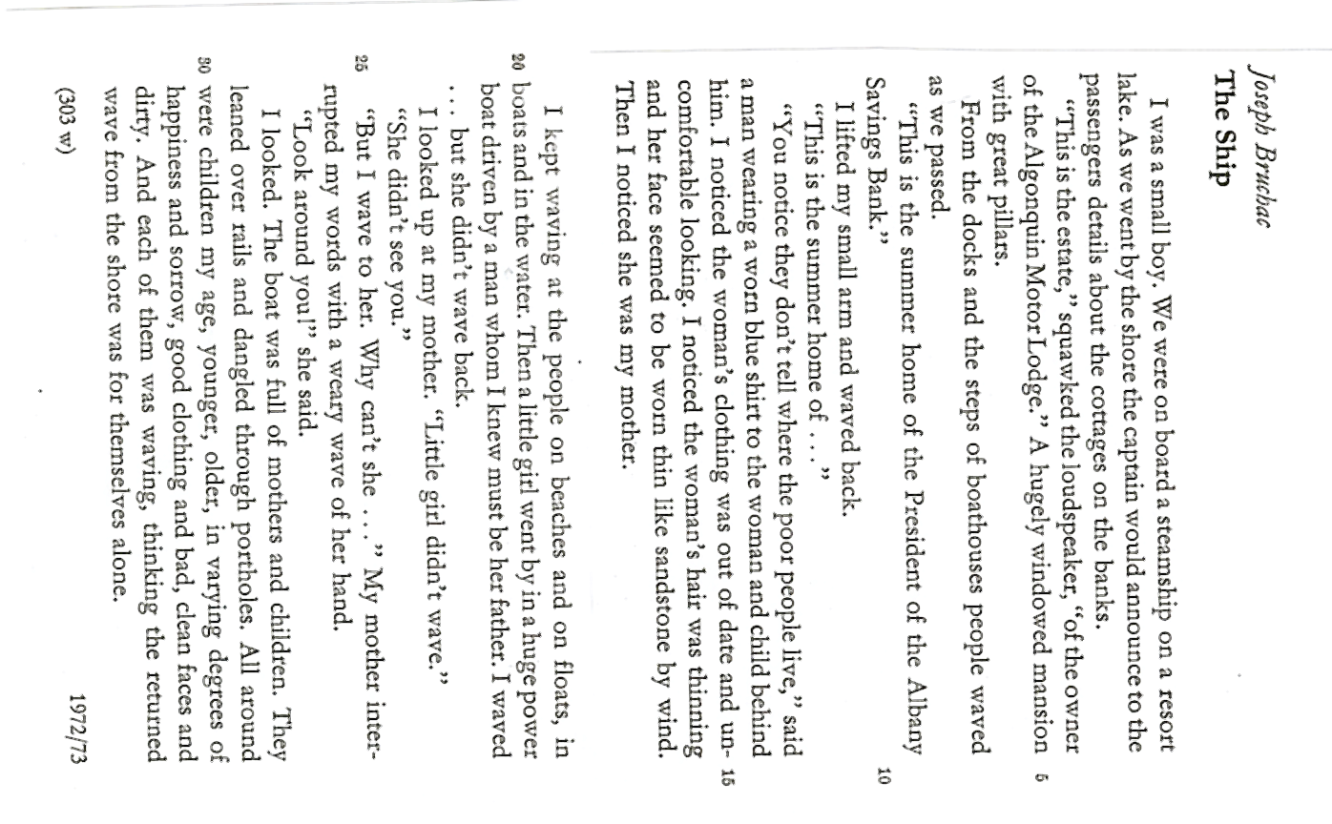
A Short Story Recipe
What are the typical features of a short-story? Collect your ideas in your group and produce a 'text-recipe' for writing a short story. What ingredients do you need? How do you use and combine them to create a successful short story?

Ace your next Short Story
No Soaps, Please!

Tips for writing a short-story

- Little 'action': Most of the best short stories include very little 'action'. They concentrate upon what happens in a few days, hours, or even minutes and focus on the experience of one or two people. Don't tell people's life stories.

- Be truthful: The reader must believe what you're telling him/her. Avoid exotic events and dramatic developments. Start with everyday experiences – if possible with an experience you have had yourself. Change little details as you need them.

- Describe your main character(s) vividly. Bring them on by showing rather than telling how they feel about certain things. Show how they walk, talk and dress. Think about the way they behave in typical ways (e.g. fidgeting, striding up and down, pacing up and down, chewing gum, humming contently...) Do they speak in full sentences or are they using short, abrupt phrases? Do they use slang or formal language? Give your characters fitting names.

- Describe the setting: Create a sense of time and place. Decide on the time of year, the weather and think how these affect your place. Use colors, sounds or even subtle smells to create a multidimensional, plausible background for your story. You can easily add 'color' by using brand-names (e.g. He jumped into his Porsche or on his brand-new KTM mountain-bike...), place-names (towns, streets, shops...).

- What is the problem: Before you start writing you MUST know the basic problem that your character is going to have. The problem will be more realistic if it is a small, everyday problem that your readers will be able to identify with. (e.g. feeling left out, feeling embarrassed...)

- Short, sharp, ending: What does your character learn? This is called the 'epiphany' of the story. The epiphany can be a very small, seemingly unimportant moment of insight. Don't exaggerate-- your character needn't change the world in a day. Don't spoil your story with a cliché or a sensational ending.

