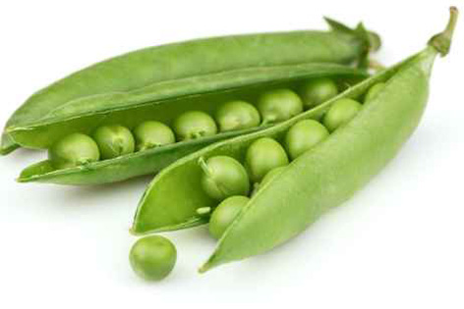
By Sarah Zurl GIBS 2c
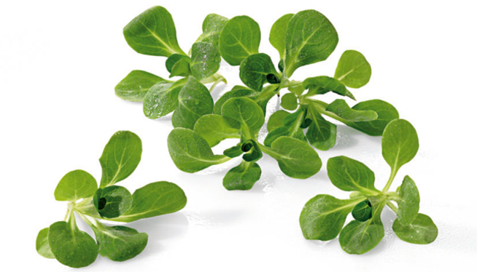




Melt the butter in a small bowl at a low temperature.
Put the mixture into a large bowl.
Next, you have to fold in the flour.
While the cake is in the oven, you could decorate the table.
Now you have to take a sharp knife to chop the walnuts/hazelnuts.
Beat the dough till all is clearly mixed.
Bake the cake in the oven for about 20 minutes.
Take a teaspoon of baking powder and add it to the mixture.
For this cake you have to peel 4 apples.
Cover your brownies with cocoa and if you want to, also with sugar pearls.
Enjoy eating your delicious chocolate cake.
Preheat the oven to 160° degree.
Be carefully, when you take the cake out of the oven!
Now you can remove the forms.
Cook the eggs in a bowl with hot water.
Place your muffins on a plate which is big enough.

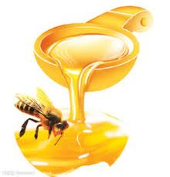
Spaghetti, Wiener Schnitzel, cakes, noodles, penne, sweets/candy, ice cream, pancakes, waffles, peas, potatoes, Nussnudeln, some fish species, broken pancakes, apples, bananas, eggs, Vogerlsalat, rice, steal, hot dog, Kasnudeln, honey carrots, cheese, pizza, egg dish, brownies, salad, muffins, cupcakes, sugar cookies, ginger bread, soup, chocolate fondue, pumpkin soup, chocolate chip cookie, chips, hamburgers, shrimp chips, tacos, döner, kebap, chocolate cake, Landfrischkäse, Gouda, Parmesan, salami, pumpkin seed oil, pea soup, honey...

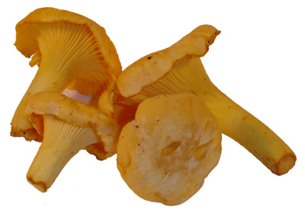
Mushrooms, shrimps, shells, tomatoes, kiwi, orange, avocados, onions, kale, broccoli, olives, plums, prunes, strawberries, raspberries, watermelon, honey melon, blueberries, carrots, celery, goat, duck, spinach, black beans, dried peas, green beans, salmon, soy beans, sardines, beans, tofu, egg plant, lamb, spiders, thunafish, raisins,...
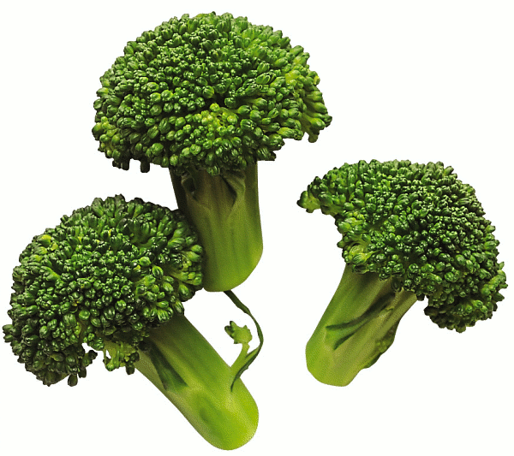
Takes 20 minutes till it’s finished.

Ingredients for 4 tarts:
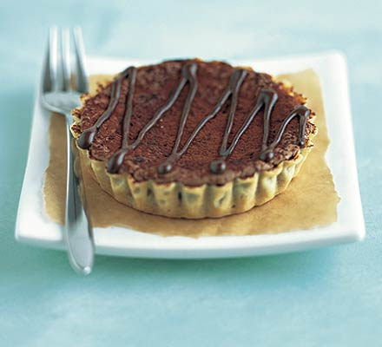
200 g plain chocolate, melted
50 g plain flour
500 g shortcrust pastry pack,
rolled out to the thickness of a
20 p piece and used to line
4 x 10 cm tart tins
4 eggs
75 g butter, melted
100 g golden caster sugar

Method:
Heat the stove to 180C/fan 160C baking you the cake, dazzle it for 12 minutes. Mix ¾ of the molten chocolate with eggs, butter, sugar and flour. Then stream it into the cake forms. Bake 6-8 minutes. Decorate with the remaining chocolate and dust it before with cocoa.

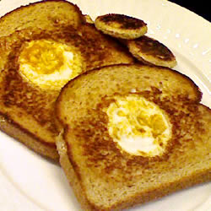

prep in 10 min
cook 20 min
ready in 30 min

Ingredients for 6 servings:
6 slices bread
2 tbsp butter, softened
6 eggs
6 slices cheddar cheese

Method:
- Preheat a large skillet to a high temperature.
- With a small biscuit cutter remove centers from bread. Butter slices on one side only. Grill bread until lightly toasted. Crack an egg into each bread hole (be careful not to break the yolk). Season with salt and pepper to taste. Lay 1 slice of cheese on each egg and then the bread rounds. Cook until eggs are cooked to your desired consistency.

Prep in 5 minutes
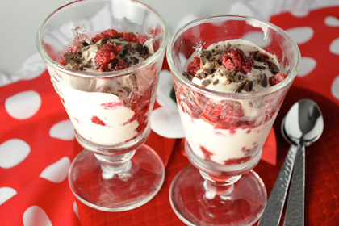
Ingredients:
½ teaspoon cocoa powder
1 teaspoon vanilla extract
2 teaspoons honey
1½ cups low-fat or fat free Greek yogurt
2 cups fresh or frozen raspberries
¼ cup shaved dark chocolate or chocolate chips

Method:
- In medium bowl, whisk together cocoa powder and vanilla.
- Add honey and yogurt and stir until they're well combined with cocoa mixture. It will turn light brown.
- Spoon 2 tablespoons of yogurt mixture into the bottom of four clear glasses.
- Top with some raspberries and repeat until all of the yogurt and raspberries are used up.
- Sprinkle each parfait with chocolate shavings.
- Serve or refrigerate until ready to serve.

Finished in 20 min
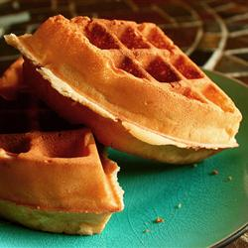
Ingredients for 6 servings:
2 eggs
2 cups all-purpose flour
1 ¾ cups milk
½ cup vegetable oil
1 tbsp white sugar
4 tsp baking powder
¼ tsp salt
½ tsp vanilla extract
Method:
- Preheat waffle iron. Beat eggs in large bowl with hand beater until fluffy. Beat in flour, milk, vegetable oil, sugar, baking powder, salt and vanilla, just until smooth.
- Spray preheated waffle iron with non-stick cooking spray. Pour mix onto hot waffle iron. Cook until golden brown. Serve hot.

Prep in 50 min
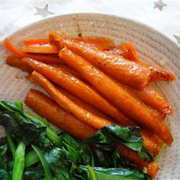
Ingredients:
8 carrots, peeled
3 tbsp olive oil
¼ cup honey
Salt and ground black pepper to taste
Method:
- Preheat an oven to 350 degrees F (175 degrees C).
- Place the whole carrots into a baking dish, and drizzle with olive oil. Mix until the carrots are completely covered with olive oil. Pour on the honey, then season to taste with salt and pepper; mix until evenly coated.
- Bake in the preheated oven until just tender, or cooked to your desired degree of doneness, 40 minutes to 1 hour.

Vegetable and Fruits:
Broccoli, cabbage, celery, chickweed, lettuce, carrots, peas, potatoes, seaweed, cherry, mango, chestnut, grape, hazelnut, plum, raspberry, apple, apricot, avocado, banana, melon, walnut, blackberry, orange, coconut, tomatoes, che, olives, citron, Clementine, cranberry, crowberry, elderberry, lemon, lime, mandarin, strawberry, nectarine, peanut, pear, pepino, pistachio, pumpkin, wampee, cloudberry, loganberry, salmonberry, thimbleberry, bearberry, bilberry, blueberry, falberry, huckleberry, lingonberry, strawberry, breadfruit, blackcurrant, grapefruit, kiwi, pineapple,...
Ingredients for baking:
Apples, baking powder/baking soda, blueberries, butter, chocolate, cranberries, eggs, corn syrup, lemons, nuts, peaches, pumpkins, raspberries, strawberries, vanilla essence, yeast, salt, cocoa, milk, oil, honey, water, juice, almonds, biscuit, blackberries, brown sugar, bun, butter cream, buttermilk, caster sugar, cheese cream, cinnamon, coconut, colouring, cookies, corn flour, cream of tartar, custard, dried yeast, edible dust, edible glitter, edible glue, egg white, egg white powder, fresh yeast, gel colouring, ginger, glace icing, glaze, glitter, golden syrup, granulated sugar, gum paste, hazelnuts, icing sugar, jam, jelly, gelatine, marzipan, pie, sprinkles, walnuts, ...
. . .

Adverbs,...:
baked, brown, chilled, cold, cooked, cooled, crisp, crumbly, crunchy, delectable, disposable, dry, fluffy, foamy, gooey, grated, grease proof, ground, hard, heaped, hot, large, lovely, melted, mild, moist, non-stick, overcooked, pliable, powdered, raw, runny, soft, sticky, tacky, tasty, tender, thick, thin, tough, undercooked, yummy, enjoy, well, good, perfect finished

Verbs:
To add,
to bake,
to beat,
to boil,
to coat,
to combine,
to cook,
to cool,
to cover,
to cream,
to curdle,
to cut,
to defrost,
to dry,
to fill,
to fold,
to freeze,
to grate,
to grease,
to heat up,
to keep,
to knead,
to leaven,
to leave to stand,
to line,
to melt,
to mix,
to mix together,
to modle,
to over mix,
to pipe,
to place,
to pour,
to preheat,
to preserve,
to put pressure on,
to roll out,
to set aside,
to settle (down),
to shake,
to sieve,
to sift,
to smooth,
to soften,
to spread,
to sprinkle,
to squeeze,
to stir,
to store,
to thaw,
to thicken,
to tint,
to under mix,
to warm up,
to whip,
to whisk,
to wrap

