2/1/2012
Book Project: Teens in Trouble | .
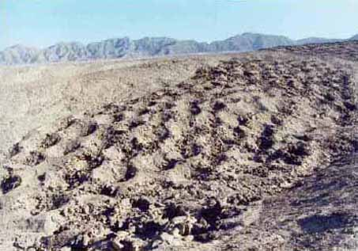
Rosa, Anna, Benjamin Koko | HOLES

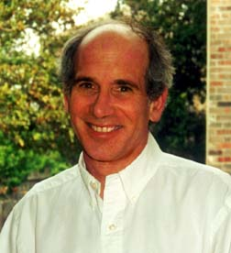
About the Author

Born in New York on March 20th, 1954, Louis Sachar is the author of “Holes” and many other children’s books. He lived in New York until the age of nine and then he moved to Tustin, California. In Tustin he had “epic orange fights” with the local kids. Nowadays the orange trees are gone though, replaced by fast food restaurants and stores. Luis enjoyed school and was a good student. He started reading a lot at high school. The authors J.D Salinger and Kurt Vonnegut finally inspired his career as a writer. After high school, his father died and he moved to his mother. There he had a very short but successful career as a door-to-door salesman, selling cleaning products. He finished college with a major degree in economics. After graduating, he started to write the story which would eventually become famous as the “Sideways Stories from Wayside School”. All the characters were based on kids he knew from college. It took him nine months to write the book. After that, he decided to go to law school. He finished law school in 1980 and continued writing, but as a side – job he did part-time legit work. Finally, in 1989 his books began to sell well enough that he could fully concentrate on writing books. He married his wife Carla in 1985. They have one daughter, Sherre, who was born in 1987. They now live in Austen, Texas. If you are looking for Luis, go to the Bridge clubs in Austen, where he is often found competing in small, local tournaments.

Prison or Camp Green Lake
Inner Monolog of Stanley (you need to remember, he is sent there innocently, so his thoughts are very confusing to read), at the scene where Stanley may decide whether he wants to go to prison or Camp Green Lake: What should I do? Go to prison or to Camp Green Lake? In prison I would need to stay longer than in Green Lake, and at Green Lake there will be a lake. But there has to be something behind it! Why would they offer me to go to Green Lake, if it was nice there? How will I catch up for school? I don´t know where I should go, but I need to decide quickly. I am innocent! The shoes fell from the sky. I didn´t steal them!! Camp Green Lake might be a bit nicer than prison, because in prison I won´t get much to eat, and in Camp Green Lake I could go swimming. I am not sure what will await me there, because it has to be a punishment, otherwise court wouldn´t offer it to me! I think I once heard about a boot camp in the desert, where they had to dig a big hole every day, but I like digging holes. Why do I need to go there? What did my no-good-dirty-rotten-pig-stealing-rotten-great-great-grandfather do? What will await me in Green Lake?

Camp Green Lake was a camp where juvenile criminals were sent to form their character. The book Holes takes place in it. In the book, Green Lake turned into a desert when Trout Walker shot Sam, Kissing Kate Barlow’s boyfriend. After that she became a criminal and buried her treasure somewhere on Green Lake. Where, remained a mystery for many years…
1: The entrance to Camp. There is a sign on which “You are entering Camp Green Lake Juvenile correctional facility”, was written.
2: The Wardens hut. She owns the camp, the two old oak trees which provide the only real shade for hundreds of miles and the hammock hung between them. The Warden is an evil woman whose family had been searching for the treasure since generations. She uses the camp as a way to find it.
3: The Wreck room. In it there are loads of old games and places to sit. It is used to relax after a long day of digging.
4: The tents. A – E where for the campers, F was for the Staff.
5. The showers. Each boy was allowed 1 four minute cold shower a day. Unless they found something, then they could have double showers.
6: Stanley´s first hole. “The first hole is the hardest”, X – Ray said to Stanley once. He was wrong. Each hole just got worse.
7: The Upturned boat. Under it, Stanley and Zero find shade, shelter and “Sploosh” when they try to run away.
8: The Gods thumb. It is said, that it is the only way to leave Green Lake alive. No one knows why, but Stanley and Zero still try to head for it. Will they make it? Read the book to find out.
9: The last hole. Stanley’s and Zero´s last hole. They find a suitcase and yellow spotted lizards in it.
Shoe-recycling Machine
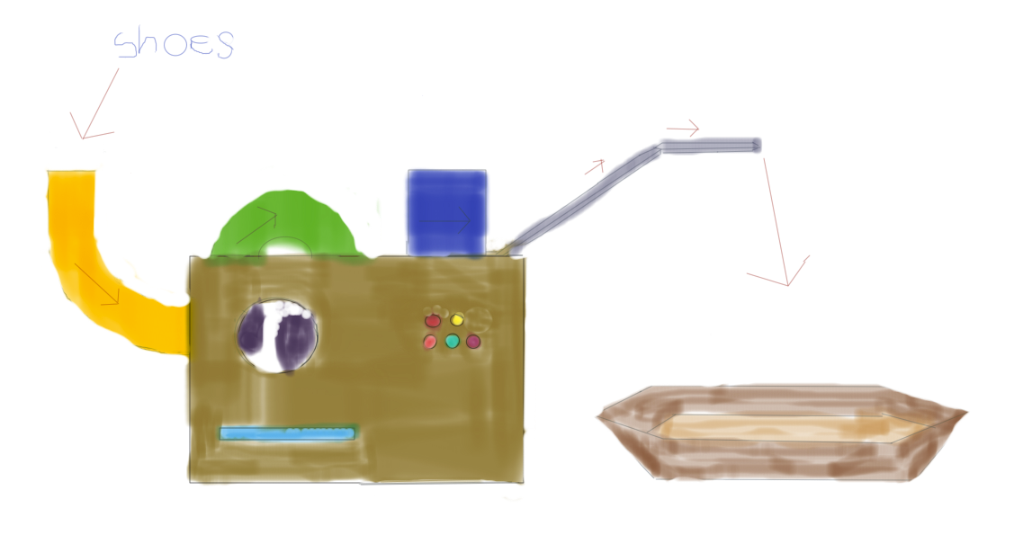
First of all, I have to say that this machine is only useful for families with children, because it is making shoes to diapers. This machine is the first successful invention of Stanley Yelnats’ father. It’s a machine for recycling any kind of shoes very efficiently. First you put the shoes into the yellow pipe and then you press first the turquoise and then quickly the yellow button. While the machine is recycling the shoes, you can leave it alone, because the recycling process takes approximately half an hour. When the machine is finished with recycling your shoes, they will go up a treadmill and then just fall into the intended basket on the floor. So when you come back, the fresh diapers will already be there for your use. It’s medically proved that the substance is not harmful for the skin of the baby or little child. With this machine you can save a lot of money that you would normally spend on new diapers. AND, you get rid of your old shoes that you don’t use anymore, very efficiently too!!
So it’s only an advantage to buy this machine. Sale only at Stanley Yelnats´ senior personally. We wish you much fun with the product!!

Spiced Peaches (Sploosh)
Makes 7 to 8 servings.

INGREDIENTS:
4 peaches
1 cup vinegar
1 cup cinnamon
1 cup cloves
3 cups brown sugar
1 tablespoon ginger
1 tablespoon salt
1/8 pepper
1. Boil spices together to make spiced syrup.
2. Add peaches to another biling pot.
3. When peaches are tender and warm, add peaches and syrup to a blender. Then put in a crock-jar. Sploosh (:
For serving: If you have guests and want to make spiced peaches for the dessert, the guests would be totally impressed if you may decorate with some strawberries. It fits perfectly to the sweat taste of the peaches and tastes very exotic with the spices.
Camp Green Lake is the ideal place to send all the teenager prisoners to. It is the most horrible and punishing camp the world has never seen before. The food is not good, it is in the middle of the desert and every day they have to dig a huge hole. Escaping from our camp is impossible because if they tried to do so they would be killed by one of the lizards in the desert or die in the desert because of hunger or thirst. So there is no way out of it.
It is for free and you can send your children to us at any time you want to. If you are interested just fill out the slip below and mail/bring it to our office.
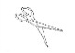
_ _ _ _ _ _ _ _ _ _ _ _ _ _ _ _ _ _ _ _ _ _ _ _ _ _ _ _ _ _ _ _ _ _ _ _ _ _ _ _ _ _
APPLICATION FORM FOR CAMP GREEN LAKE

Name of your child: ___________________
Date of birth: ___________________
Crime committed (why you want to send your child to our camp): ___________________
Date of arrival: ___________________
How long will your child stay: ___________________
Signature of parent or legal guardian: ___________________

Diary entry of the warden:
Dear diary!
As you know, I’ve been searching for a clue or a hint or something important for years, with my parents, and now I’m still searching. Although my parents died a long time ago, their will kind of, possessed me, I kept thinking of the treasure, that Kissin’ Kate Barlow has hidden somewhere in Camp Green Lake. And now!! FINALLY!!!!! X-ray, found something, that could somehow be related to the treasure!! It’s a tube of lipstick, the lipstick from KATE BARLOW!! I knew exactly what to do: I ordered X-ray and all the other kids in his group to dig at the spot where he said he found it. If I’m lucky, we’ll find it! Or so I thought. But after a day of digging right on the spot, I just got fed up with waiting, so I let them go to sleep. On the next day, I made them dig again, on the same spot, but I already was a bit impatient. We, again, found nothing. I think that one of the other boys found it and brought it to X-ray, because he was the kind of group leader and they had to bring it to him, if they found anything interesting. Gosh! I hate children!! They are so stupid! I’m really so fed up with this whole thing!! I really would like to stop with this and just get a normal job, marry a nice guy and get children, but I’m so possessed of this damned treasure!! Oh my dear God!! But I will not give up! I will fight for this treasure! Because if I would really find it, I would have safe hands for the rest of my entire life!!!! But if these boys are so stupid, I’ll become crazy!! The whole treasure: MINE!! Okay, sorry, I have to stop writing, I’ve got lots of work to do!!
Yours, The Warden

Camp Green Lake closed

Yesterday Ms. Walker also known as the Warden, declared bankruptcy of Camp Green Lake, where youths accused of crime had to dig holes to form their character. Consequently, the camp now has to be closed. The land was bought by a national organization, which dedicated it to the well-being of young girls. In a few years the camp will no more be a punishment, but a Girls Scout Camp. Ms. Walker, who had to sell the land that had been in the possession of her family for over generations, was said to have tried to find a treasure of Kissing Kate Barlow. Another source of us says that the treasure was found by one youth, who then hid it from her. She had five men working for her, and there were up to fifty youths digging holes. The workers were mostly paid with the money from the state that she got for taking up youths that were on the wrong track. Camp Green Lake functioned as an alternative to jail for ten years, and it was recently in the news, when a youth stepped on purpose on a rattle-snake to get out of there.

Who wrote which text:

Anna Hernady: “Diary Entry of the Warden”, and “Shoe-recycling machine”

Rosa Schwentner: “Recipe for Sploosh”, and “Application form for Camp Green Lake”

Benjamin Wunderling: “About the Author”, and “Event map of Camp Green Lake”

Konstantin Spiess: “Camp Green Lake closed” and “Prison or Camp Green Lake”

