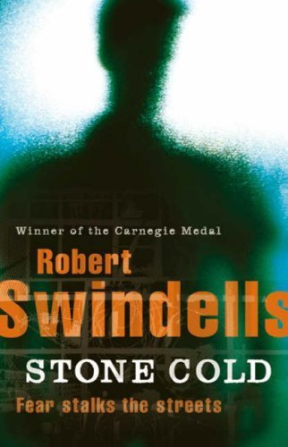

By Charis and Elisabeth

Table of Contents

- Kids Vanishing in London | p. 3
- Map of London | p. 4
- Dear Mom! | p. 6
- My Thoughts on the Train | p. 7

Kids Vanishing in London
The daily mirror
In two weeks already four kids and three women have disappeared.

On the 3. of October the first kid has vanished. Now it is the 17. And seven people are missing now! Parents get worried about their kids; they drive them everywhere and don’t let them walk alone. We have interviewed an eye witness who has seen one of the victims the last time:
The Daily Mirror: What and Whom have you seen exactly?
Witness: There was a man with a strange coat and a black hat waiting at the train station. As a boy came out he ran after him. The boy screamed and wanted to flee but the man held him very hard. I think the names Ginger and Link were said. The man looked stressed and the kid suddenly stopped yelling. But then the boy looked worried and screamed at him again I can remember the words: Hey you Bastard! Why didn’t you bring him to the Hospital! Then they walked off quickly.
The Daily Mirror: Do you know in which direction they walked off?
Witness: I don’t know really I think in the direction of Mornington place…
The Police is already launching for evidence. But the question is also where the criminal is now? Who is his next victim? Please help to find the stranger and inform them if you see something strange.

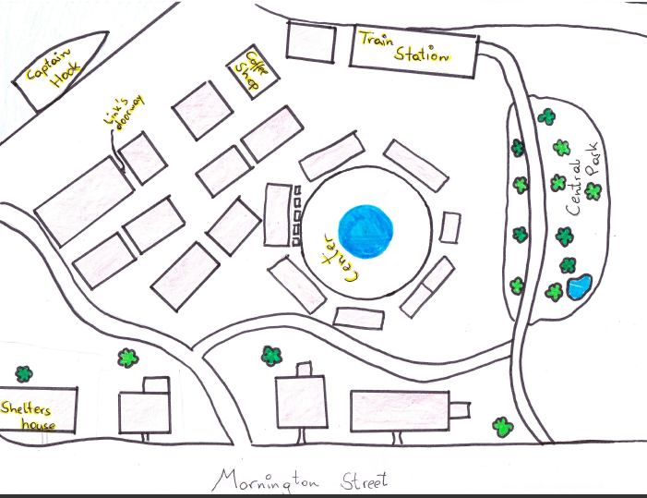

Legend:
houses
Word = Important Place
Water
Description:
Shelter’s house: His house was big and white. He had a cat called Sappho. Link and Gail sometimes sat there for hours to discover where Ginger disappeared in this house?
Center: In the Main Square Gail and Link used to beg for money and then they made a competition, who has got more money. Gail always won! But Link wasn’t upset about it because he loved here and they always shared what they got!

Captain Hook: There the two friends slept, when they had no money and no place to sleep. In there it looked like in a slave ship layer over layer the people lay in there. It was their last hope to survive.
Train Station: In this Place, Link saw Ginger the last Time. He wanted to go to his friends but never came back. Link worried about him. He thought that maybe he didn’t want to stay together with Link and so he just moved on!

Coffee Shop: There Link always drank a coffee together with Ginger. But once he was waiting for Ginger to come back he met Gail. Gail is a girl with beautiful hair and Link never thought, that such a girl would come to HIM!
Link’s doorway: This was, so to say, his “home“. There he also once got attacked by another homeless guy and he changed doorway. But he liked it there so he came back and met Ginger. Ginger showed him London from all his sides.

Shelter’s house: His house was big and white. He had a cat called Sappho. Link and Gail sometimes sat there for hours to discover where Ginger disappeared in this house?
Center: In the Main Square Gail and Link used to beg for money and then they made a competition, who has got more money. Gail always won! But Link wasn’t upset about it because he loved here and they always shared what they got!



Dear Mom,
Only a few days ago, I was sitting in doorways on the streets of London with nothing but a few pence and a sleeping bag. All I did was walking around all day, begging desperately for money and food in the cold and windy streets. I was hungry but had nothing to eat. I was thirsty but had nothing to drink. I was tired but had no bed to sleep in. All I had was my friend Ginger. He was the one who showed me around and helped me to survive. Without him, I probably wouldn’t be alive anymore. But all at once he left and never came back. If you had any real friends who weren’t drunk 24/7, you would know what it feels like, when the only important person gets knocked out of your life like a billiard ball.
I also met a girl, Gail. Together we found out that Ginger was murdered by some mentally ill guy. Then later I discovered that Gail was actually a journalist who had used me to investigate the murder, but she also left, after helping me to find a home and get a job. Why do I keep getting separated from every person in my life even though there are only so few?
However, I do certainly not regret my decision to leave my home one and a half years ago. I can now start my own life and leave my past behind me. You haven’t contacted me since I left and please don’t do so ever, don’t waste your time thinking of me even once again. I hope you have a good time together with Vince.
Your son,
Link
My Thoughts on the Train

I can’t believe I’m really going. What’s it going to be like, all alone in London? What ever happens, I’ll manage. Still I'm kind of mad at my sister. Why didn’t she defend me from Vince that Christmas, like she always did? Instead she and Mom bought me a warm, watertight sleeping bag for really cold and rainy winter days outside in the cold and stony doorways. I guess this was a clear sign for me to leave. That I had washed out my welcome even at my sisters. If Mom wouldn’t have fallen in love with a stupid git like Vince, this all here hadn’t happened. Vince has stolen my family and my home. So, what else is there to do other than leave? I could kill him if I wanted, but that would break my Mom’s heart. Well, she also broke mine, so what’s the problem? Still, I hope that leaving is the right decision. I really hope so.
I visualized my leaving and saying goodbye a bit differently. I thought that they would at least cry. My sister handed me a pack of cash and gave me a hug. But you could see she wasn’t crying. My mom wasn’t even sad. This is the actual reason I had my huge clump in my neck. I had the feeling of being kicked out of the family without any tears. Like they rammed a knife into my body and left me bleeding. Hopefully I’ll find a better life in London.
I'm on the train to a beautiful place called London. I’ve said that already. I actually don’t know what this place looks like because I’ve never been there, but it will certainly be nicer than that close to home. I'm thinking about my future and my past, even though I want to forget it. Maybe I will get a job and find a house, maybe even meet a girl and have kids. Oh what nonsense I'm thinking. I have got nothing but this stupid sleeping bag and my watch which I got from my mom before Vince came. However Ill try my best there for sure.

